Evaluation of Credit Union services in Oxford

Final Report
July 2015

Report produced by Financial Inclusion Centre
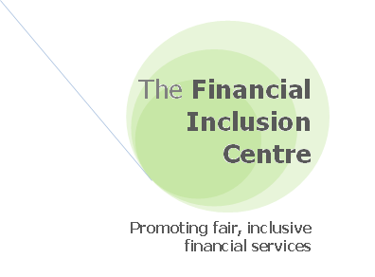

The Financial Inclusion Centre is an independent research and policy innovation think-tank dedicated to promoting financial inclusion and fair, efficient, competitive and accountable financial markets.

The evaluation research was researched and written by:

Gareth Evans (Director)
Gareth is a specialist in research, evaluations and policy formulation covering financial exclusion, overindebtedness and community finance, with over 12 years’ experience in the field. He has built extensive knowledge and practical expertise in extending access to affordable financial services particularly in relation to credit unions having undertaken a diverse range of feasibility, development, training, product development and strategic business growth work across the sector.

www.inclusioncentre.org.uk.
Contents
Executive Summary 4
1. Introduction 10
1.1 Project aims 10
1.2 Research methodology 10
1.2.1 Research management arrangements 10
1.2.2 Research approach 11
2. Credit union services in Oxford 13
2.1 Oxfordshire Credit Union 13
2.1.1 Background 13
2.1.2 Current financial and growth analysis 15
2.1.3 Strategic priorities and financial projections 16
2.1.4 Summary of main strengths / weaknesses 17
Financial and business growth 17
Operational and service delivery 18
2.2 Blackbird Leys Credit Union 20
2.2.1 Background 20
2.2.2 Current financial and growth analysis 21
2.2.3 Strategic priorities and financial projections 23
2.2.4 Summary of strengths / weaknesses 24
Financial and business growth 24
Operational and service delivery 25
2.3 Direct comparison of the two credit unions 26
2.3.1 Key financial indicators 26
Chart 1: Total adult membership levels (actual and projected) 27
Chart 2: Total net assets (Actual) 27
Chart 3: Total member shares and loan balances (actual and projected) 28
Chart 4: Net profit (actual and projected) 28
Chart 5: Income and expenditure (actual and projected) 29
Chart 6: Capital reserves (actual and projected) 30
2.3.2 Product and service delivery: 30
2.4 Potential merger of the two credit unions in Oxford 32
3. Recommendations for expanding and enhancing credit union services in Oxford 34
3.1 Recommendations to credit union services in Oxford 35
3.2 Recommendations to Oxfordshire Credit Union 37
3.3 Recommendations to Blackbird Leys Credit Union 40
3.4 Recommendations for Oxford City Council 42
Appendix 50
Appendix 1 - Audited Annual Accounts: Income and Expenditure (BLCU and OCU) 50
Appendix 2 - Audited Annual Accounts: Balance Sheets (BLCU and OCU) 51
Appendix 3 – Deprivation levels in Oxford 52
Appendix 4 - Social housing providers in Oxford (and Oxfordshire) 54
Appendix 5 – Number of Employers based in Oxford (with over 200 staff in Oxfordshire) 56

Executive Summary

With the government’s changes to the Welfare System, the ability to access appropriate financial services and manage household finances has never been more important. Oxford City Council (OCC) is committed to increasing financial inclusion and tackling overindebtedness as part of its Financial Inclusion Strategy.

Credit unions are an important component of this work, promoting financial resilience and providing access to affordable credit and other banking services to those who might otherwise struggle to access such services. Oxford has two very different credit unions operating across the city. This is ultimately not productive as it duplicates effort, dilutes increasingly scarce resources and limits take up by offering a confusing message to potential users.

The Council has provided significant funding to both Credit Unions to support their development and most recently to facilitate a potential amalgamation. This research was commissioned following the breakdown of the merger discussions. It is designed to evaluate both Oxfordshire Credit Union (OCU) and Blackbird Leys Credit Unions’ (BLCU), financial situation, growth and strategic direction and Business Plans for growth and identify opportunities for improvements. This has be framed within the context of wider best practice from across the sector, in order to set out a series of recommendations for the individual credit unions and Oxford City Council, with a view to enhancing and extending provision and maximising uptake.

Oxfordshire Credit Union
Operational for almost 10 years, and has grown steadily to become the larger of the two credit unions, both financially and in terms of its membership. It has undergone significant recent change, extending its services to deliver service across the whole of Oxfordshire and more recently in 2014, completely restructuring its business by closing its main office and getting rid of all staff and replacing it with an established back-office service provider to manage and deliver its core operations. This aims to reduce its operating costs and make it more financially viable while offering a more consistent and comprehensive service with a greater range of products that allows it to expand its reach and focus on strategic growth.

It now serves 730 members and plans to grow this to 1,250 over the next three years, which is relatively small compared nationally to an average credit union membership of just under 3,000. Financially, it offers a mixed picture with healthy annual growth in net assets and members saving deposits of approximately 20% that should see it reach over £500,000 in assets by 2017 from its current levels of just over £425,000. Yet, its loan portfolio has fallen by 25% over the last two years together with relatively high levels of non-performing loans. This is OCU’s most critical challenging and projects to increase lending by 75% increase over the next three years.

By taking proactive measure to address its financial profitability, OCU has cut its outgoings by 14% over the last two years, while managing to keeps its income stable. This has resulted in cumulative net profits of almost £4,000 since 2012 that have been invested in its capital reserves to continue to strengthen its viability.

Key strengths:  - Strong financial growth of just under 20% in net assets and members shares.  - Relatively profitable over last two years with proactive measures taken to reduce expenditure (projected to fall by one third) and plan to reduce grant reliance to below 15% of income over next 3 years.  - Business focused board with good level of skills/competencies and sensible projections within strategic business plan.  - Broad common bond offering economies of scale and business growth opportunities via partnerships and payroll deduction  - New back office service provides consistent /quality service at a reduced cost and capacity to deal with demand together with ability to deliver remotely via online, telephone and face-to-face outreach services.  - Excellent branding and new website. | Key weaknesses:  - Low membership base.  - Main financial concern is its reducing loan book that has contracted by a quarter over last 3 years together with high recent delinquency - but signs that this is improving.  - Income has fallen due to lower lending and is still reliant upon on grant funding for over 40% of its income.  - Adequate reserves but could have implications for ability to grow while continuing to meet capital requirements.  - Needs to continue to improve service delivery to support more remote access and communication via technology improvements and develop greater product range.

Blackbird Leys Credit Union
The credit union has been serving the Blackbird Leys or Greater Leys area for over 20 years. While it is still relatively small with a membership under 500, it actually serves about 3% of the local population.

BLCU has a very traditional approach with a narrow product range and service delivery model that focuses on operating from a single office that is open less than a third of the week. The office is run by a small team of part-time staff and allows members to deposit and withdraw cash, which it believes is an essential part of serving the most financially excluded members. Last year it voted to expand to cover the entire city but without significant improvements to its service delivery and capacity, it is very difficult to see how it can serve potential members outside the immediate community.

In terms of its finances, BLCU has a series of concerning trends that would point to a credit union experiencing overall decline that unless addressed, leave questions about its medium term viability. Over the last three years, its assets have fallen 11%, saving deposits are down 7% but most troubling is its lending levels which have plummeted by 68% to under £20,000 out on loan on its books. It also has relatively high delinquency level. This situation is not sustainable and the credit union must focus on at least tripling its current lending levels in a prudent manner but this will be especially difficult given internal factors such as its restrictive loan policy/practices and its relatively high default levels, coupled with its external circumstances such as its narrow focus on a small operational area that is relatively deprived.

The knock on effect of these declining figures is being felt in its profitability and ultimately its viability having last year, registering a net annual loss of £9,276 driven by the steep decline in
income, (equivalent to 51% drop over the last three years) that has not been matched by sufficient reductions to its operating costs, which only dropped 28%. Moreover, it is heavily
reliant upon grants and donations to operate the business, representing two thirds of its current income.

Importantly, the credit union’s redeeming financial feature is its strong capital/asset position with reserves of over £13,000 yet without significant address of its financial problems, this will continue to be eroded. Without a completed business plan which is an important regulatory requirement, it is difficult to identify just how BLCU is planning to address these matters. It recognises that the solution is to undertake a transfer of engagements into a larger neighbouring credit union but it is not clear how likely this will be. A previous attempt to merge the two credit union services in Oxford failed at the last moment and while both parties have not ruled out further discussions, there would be a number of hurdles to overcome.
Key financial headlines  Bracket show average British CU | OCU  Brackets show % change from previous year | BLCU  Brackets show % change from previous year
Membership (2,951) | 730 (-33%) | 456 (-3%)
Net Current Assets (£3.47M) | £436,735 (17%) | £162,748 (-10%)
Total Savings (£2.96M) | £426,029 (18%) | £149,305 (-5%)
Annual dividend (n/a) | 0% | 0%
Total Loans (£1.98M) | £137,140 (-19%) | £18,949 (-45%)
Loans as % of shares (67%) | 32% | 13%
Total Income (£71,000) | £75,258 (-6%) | £19,956 (-50%)
% income from grants (n/a) | 41% | 78%
Total Expenditure (£62,000) | £75,486 (0%) | £29,141 (-26%)
Total profit -after tax (£9,000) | £-793 | £-9,276
Capital Reserves (0.37M) | £10,706 (-7%) | £13,443 (-41%)
Capital asset ratio | 3.4% | 8.9%
Liquidity ratio | 51.3% | 32.0%
Bad debt write-off (n/a) | £26,818 (-12%) | £6,371 (?)

Key strengths:  - Financially, BLCU has a strong capital position – with current capital/asset ratio of almost 9%.  - Long history with strong connections in local community.  - Dedicated staff team and long serving and experienced Directors – but highly reliant upon one or two individuals to maintain operations. | Key weaknesses:  - Declining membership with narrow low-income profile concentrated on households.  - Contracting across almost all financial indicators with annual falls of 10% in net assets, 5% in shares and 45% in lending.  - Posted a £9,000 deficit last year and without sizable action to reduce expenditure and increase income, raises serious concerns over short-medium term viability.  - Lending has dropped by 68% in over last 3 years to just under £20,000, equivalent to 13% of shares out on loan. This is compounded by difficulty in quickly expanding productive lending due to small operational area and limited loan policy/practices and high but improving default levels.  - Needs to address its lack of business or financial plan - a serious regulatory failing.  - Extremely high grant dependency with only 22% of its income generated – a particular risk in current climate of public sector cuts  - Traditional delivery model that is high cost for scale with poor levels of service, capacity and product range that severely limits ability to grow and reach people living outside immediate area (let alone entire city).  - Very poor branding and substandard website.

Recommendations
The report contains a comprehensive list of 48 suggested actions and improvements for the two credit unions and Oxford City Council with the following key headlines:

Recommendations to credit union services in Oxford
- Become successful social businesses that focus on operating profitably and sustainably in order to deliver greater social impact and serve those most excluded.
- Greater collaboration to achieve economies of scale, operational efficiency and long-term success in expanding credit union services.
- Broaden the membership base by product diversification and expanding delivery method to attract all parts of the community and meet the expectations of modern consumers.
- Increase productivity of the loan book by developing effective loan policies and competitively priced loan products with more efficient processing and convenient delivery.
- Ensure strong and effective governance to meet changing business priorities and new regulatory regime through recruitment of skilled Directors and development programmes

Recommendations to Oxfordshire Credit Union
- Utilise credit reference agency information to support membership ID verification, credit and affordability assessments during loan consideration and the building of credit rating for borrowers.
- Develop instant online membership and loan applications to make it as simple, quick and pain free for Oxford residents to join and borrow and help reduce costs to the business.
- Consider introducing capacity based lending with more rigorous income and expenditure assessments of capacity to repay together with higher interest rates for small value loans.
- Develop secure online banking services to provide more functionality for members and help reduce operating costs through member self-service.
- Focus on expansion of payroll deduction as an untapped growth opportunity by increasing the number of employers offering this facility and maximising penetration levels.
- Seek capital investment through subordinated loans from partner organisations to facilitate growth and release additional funding for development.

Recommendations to Blackbird Leys Credit Union
- Strongly reconsider a strategic merger with OCU to address financial viability issues and ensure that a viable service can continue to be delivered in the community.
- Immediately prioritise the production of a business plan and undertake an internal compliance review to identify any other regulatory requirements not currently being met.
- Increase loan book to generate more income by increasing lending volumes and provision of more profitable higher value loans.
- Accelerate efforts to reduce operating costs by cutting staffing levels further and substituting with volunteers to maintain delivery levels and core operations.
- Strengthen the Board to address identified business continuity risks and new regulatory requirements, if the credit union is unable to secure a suitable merger.

Recommendations to Oxford City Council
If the Council wishes to see credit union’s enhancing and expanding their services, it will need to play a more direct role. In light of the situation with the two credit unions, it would be counterproductive to temper action, in the interests of being fair to both. Pursue resumption of merger negotiations with the Council playing an active role in facilitation and utilising support and resources to encourage the direction of the process.
- Facilitate approaches and engagement of senior representatives at local employers, Council suppliers, social housing providers and other key stakeholders to provide support for the credit union, especially through payroll deduction partnerships.
- Co-ordinate a comprehensive marketing strategy for the various Council communication channels, to increase awareness and uptake amongst Oxford residents.
- Determine its overall strategy for supporting and resourcing credit union services that maintains short-term commitments to revenue funding but that looks to reduce its support to encourage sustainability potentially through the use of one-off investment for modernisation and capital funds.

Introduction

In the current economic climate and the government’s changes to the Welfare System, the ability to access appropriate financial services and manage household finances has never been more important. Being financially excluded imposes real costs not just on individuals and their families, but also on the wider communities and economies in which they live.

Oxford City Council’s (OCC) is commitment to reducing inequality within the city and sees that tackling financial exclusion and overindebtedness as an integral part of this vision. As a response, it has developed a detailed three year strategy and action plan to deliver financial inclusion work that links to it wider work on welfare reform, fuel poverty and stronger communities agendas.

Within the city, there are already a number of organisations delivering financial services and providing access to money advice support as well as significant work taking place across the Council that contributes towards the reduction of financial exclusion. Credit Unions are an important part of this work, which can promote financial resilience and provide affordable credit and other banking services to those who might otherwise struggle to access such services. Oxford has two very different credit unions operating across the city.. Yet, despite ongoing support and investment of resources by the Council, less than 1,500 people, equivalent to less than one per cent of the Oxford population are currently accessing credit union services. Furthermore, the current position and condition of each credit union and their potential to contribute toward the financial inclusion agenda is not fully understood.

Project aims
The report aims is to evaluate current provision of credit union services within the city, examining the financial circumstances, growth and strategic direction of each credit union, comparing their service delivery approaches and product offers and outlining their individual strengths, weaknesses and opportunities for improvement. This will be framed within the context of best practice identified from across the sector, in order to determine how best credit union services can be enhanced and extended to maximise uptake, benefit and contribution to the city’s financial inclusion aspirations. A series of recommendations are proposed for both Oxford City Council and the individual credit unions to improve provision and take up of credit union services.

Research methodology

Research management arrangements
Oxford City Council commissioned the Financial Inclusion Centre to undertake the evaluation between May 2015 and June 2015 by Gareth Evans, Director of Financial Inclusion Centre. The management of the project was overseen by Paul Wilding, Revenues & Benefits Programme Manager. The research team undertook initial project exploration discussions with the project contact to help understand the main requirements and perspectives and during the research maintained regular contact.

Research approach
The research approach has been formulated to meet OCC’s identified research requirements within its tender specification and included:

Desk based analysis of key credit union documents of both OCU and BLCU
The research team requested the following documents:
- Strategic Business Plan – covering current financial years and two subsequent years
- Audited Accounts - for financial years ending September 2014 and September 2013
- Annual Returns - for financial years ending September 2014 and September 2013

The only document that was unable to be obtained within the research timeframe was BLCU’s 2013 Annual Return which was not forwarded despite a number of requests. As also addressed later in the report, the current Business Plan provided by BLCU was lacking significant information and required sections and would not meet the compliance requirements of the regulator.

In addition, each of the credit union’s websites was accessed to gather information on product portfolio, service delivery methods and customer access.

Individual face-to-face consultation meetings with each of the two credit unions:
The research team undertook separate interviews with representatives from both BLCU and OCU at their respective offices. Each interview was recorded.

- Blackbird Leys Credit Union – Monday 11 May 2015 (12:00-14:00)
- Jim Hewitt – Treasurer
- Saul Goode – Office Manager

- Oxfordshire Credit Union – Monday 11 May (14:30-16:30)
- Mark Luntley - Chair
- Peter Stevenson – Treasurer

Desk based review of existing research within the credit union sector
To help identify various best practice and key challenges facing the credit union sector, the research team identified and reviewed a number of studies previously undertaken:
- Cato, M.S, Bickle, R, Bird, A, and Myers, J, (2009) ‘Realising the Potential: A review of the credit union movement in Wales’. Welsh Assembly Government.
- Goth, P, McKillop, D, and Ferguson, C, (2006) ‘Building Better Credit Unions’. Joseph Rowntree Foundation.
- HM Treasury, (2014) ‘British credit unions at 50: Response to the call for evidence.’
- Hope, S, (2010) ‘Promoting the Effectiveness and Efficiency of Credit Unions in the UK.’ Friends Provident Foundation.
- Jones, P, (2005) ‘Creating Wealth in the West Midlands through Sustainable Credit Unions.’ ABCUL.
- Jones, P, (2008) ‘From tackling poverty to achieving financial inclusion: The changing role of British credit unions in low-income communities’, Journal of Socio-Economics, 37: 2141-54.
- Jones, P, and Ellison, A (2011) ‘Community finance for London: Scaling up the credit union and social finance sector’. Santander.
- Jones, P, (2012) ‘Strategies for Growth: A research study into the progress and development of credit unions in the North East of England and Cumbria.’ Northern Rock Foundation.
- Old Bell 3 (2012) ‘An Evaluation of the Access to Financial Services through Credit Unions Project – First Year Report’. Welsh Government.

Review of Oxford Financial Inclusion Strategy and local need/demand for range of financial services /support within Oxford context:
To help understand the local priorities for reducing financial inclusion and determine how the credit union services in Oxford may contribute, the current Oxford City Council’s Financial Inclusion Strategy covering 2014 to 2017 was reviewed.

Credit union services in Oxford

There are currently two credit unions that operate within Oxford; Oxfordshire Credit Union (OCU) and Blackbird Leys Credit Union (BLCU). Both credit unions now cover the entire city, following a recent common bond expansion by BLCU but would appear to differ considerably in almost every aspect including their coverage, capacity, capability, strategic direction, financial profile and service delivery approach.

This section individually evaluates each credit union, providing a summary of their background and current developments, an analysis of their financial situation and recent growth as well as their own self stated strategic priorities and financial forecasts. Furthermore, the key financial indicators and product and service offers are directly compared together with subjective summaries of their individual strengths, weaknesses and key areas for improvement and concern.

Appendix 1 and 2 – provides three years of financial figures for both credit unions taken from their audited annual accounts for 2012/13 and 2013/14.

Finally, we discuss the recent failed merger, taking into account each credit unions perspective on the situation and whether there are any opportunities for future amalgamation or collaborative working.

Oxfordshire Credit Union

Background
OCU was authorised and registered in 2005 and began trading on 30th January 2006 following support from Oxford City Council and the Tudor Trust. Initially, it was only available to people living and working in Oxford but it extended its ‘common bond’ in 2012 to deliver service across the whole of Oxfordshire and achieve greater economies of scale and take advantages of new partnership opportunities.

Its membership and finances grew steadily over the initial years following its launch. Like many new start credit unions, it adopted a business model of delivering its services through a main office in the Temple Cowley area that offered cash deposit and withdrawal facilities for members and was operated by a small paid staff team complimented by volunteers. In 2014, it took the strategic decision to completely restructure its business and implement a brand new delivery approach in response to a combination of factors:
- Address head-on its ongoing financial viability issues that would ultimately enable the business to grow and become financially sustainable. Fundamentally, its cost base was much too high for its size and income generation being achieved therefore needed to significantly reduce its expenditure particularly on staffing and premises budgets.
- Delivering service via outlets that provide cash is an extremely costly and ineffective delivery approach that only serves a small proportion of its existing membership and limits access to potential new customers. By taking advantage of new online, telephone and other financial technologies, it could increase usage and offer a more professional and holistic service to better meet the challenges and changing requirements of diverse local consumers.
- Its longstanding Manager had given notice and the lease was ending on its office property therefore providing the opportunity for the credit union to review its operational approach and act as a catalyst for change.

As a result, it took the decision to close its ‘cash’ office and make its remaining two full-time paid members of staff redundant. The day-to-day delivery was replaced with an established back-office provider, Credit Union Solutions (www.cus.coop) to manage and deliver its core operations. This increasingly mirrors moves by a number of credit unions within the sector and internationally, including the main trade association, ABCUL through the Department of Work and Pensions CU Expansion Project to develop shared services and common back-office delivery to help drive down costs and improve services.

By adopting this new delivery model that combines technology driven improvements to access via online, telephone and card payment facilities combined with a network of community outlets to provide face-to-face outreach, OCU believes it will be able to offer a more comprehensive service that expands its reach and operating hours, reduces its operating costs by approximately one third and provides the opportunity to focus its efforts on strategic growth. Whilst the credit union recognises that there were some initial teething troubles and handful of members who were unwilling or unable to adapt to the new service, by encouraging members who have traditionally dealt in cash at their office towards the use of card/banking facilities, they feel they are supporting members to improve their financial capabilities and better deal with changing financial services and forthcoming overhaul to benefit payments via Universal Credit.

OCU also feels that there are significant opportunities offered from its new working relationship with CUS, which is a workers cooperative currently made up of five credit unions, and therefore enables it to take advantage of both greater economies of scale and joint working/sharing of best practice as well as greater flexibility, capacity and consistency in its service delivery.

To facilitate these changes it has reviewed its product offer and implemented a number of new services to improve access, including a prepayment card which can act as a transactional bank account enabling funds to transferred onto the card and withdrawn locally through the ATM system. It also has a separate PayPoint card facility that enables members to deposit cash at a large number of outlets and Post Offices across Oxford and nationally.

Finally, it has developed a number of partnerships with key local stakeholders including, three arrangements so that employees can make payments via payroll deductions and with both Soha Housing and Sovereign Housing Association, allowing their tenants, leaseholders and employees to easily join the credit union.

It is aiming to focus efforts on further relationships over the coming years to help support its growth, which despite not having any directly paid staff, it believes is now more realistic than before, given that the CUS delivery has actually released significant Director and volunteer time to develop such partnerships. From a governance position, OCU has a small but relatively professionalised Board of Directors that appears to have a good mixture of skills and competencies, particularly around finance that should stand it in good stead in relation to governance and the forthcoming FCA senior management regime but also in relation to building external confidence in the organisations.

Current financial and growth analysis
OCU is the larger of the two credit unions, both financially and in terms of its membership. Since its inception, it has grown steadily but is still relatively small with a current adult membership of 730. As can be seen in Chart 1, this has fallen dramatically from a peak of 1,095 members in 2013. This is as a result of a rationalisation of its ‘inactive’ membership to help reduce costs associated with each membership such as insurance and trade association fees.

Financially, it has total net assets of £435,000, which have importantly seen a healthy annual increase of 17% (see Chart 2) but from a relatively low base. Similarly, it continues to attract saving deposits from members, with total share capital of £425,000 that has risen by 18% over the previous 12 months from £311,940 (See Chart 3). This growth is despite the credit union not having paid a dividend for the last two years. Both of these financial indicators are positive and show the credit union on an upward trajectory.

Yet, like many credit unions, it has been a very challenging environment post financial crash that has conversely seen its loan portfolio fall by 25% over the last two year from £182,873 to a current loan balance of £137,000 (see Chart 3). The core factor in the sustainable development of any credit union is the productivity of its loan book. Unfortunately, this means that only 32% of its member shares are out on loan, which has actually fallen from 59% since 2012. This is compared to the ‘goal’ of 70-80% proposed as good practice by the World Council of Credit Unions (WOCCU). It is likely to have resulted from a general dampening of loan demand with many reluctant to take out further borrowing but more likely a much more cautious lending approach brought about through growing loan delinquencies.

This results in highly unproductive liquidity levels of 51% and would normally see drastic reductions in income because of falling earned income generated from loans but also that returns on funds deposited with the bank are at an all-time low. However, despite this 25% fall in lending, it has not materialised in serious reductions in earned income from loan interest, which has only actually fallen by 8% in the last two years. This is likely to have been offset by it charging higher interest rates for its smaller loans under £2,000, helping provide better profit margins.

Also of concern, are the credit unions relatively high levels of non-performing loans, which again is being seen across many credit unions. This can arise from a combination of internal factors such as poor lending decisions or from a lack of credit control as well as the increasing financial squeeze on many households. During 2014, OCU wrote-off of almost £27,000, which is of particular concern as it amounts to at least 35% of their income, equivalent to bad debt levels at approximately 20% of the current loan book. However, its default levels appears to be an improving picture with significant falls in arrears levels from £28,339 to £8,470 in the last year and reducing provisioning for doubtful debt, which fell from £20,576 in 2013 to £5,122 in 2014.

As discussed, OCU has taken proactive measure to address its financial viability that should now improve its future profitability. Back in 2012, the credit union registered an annual loss of £11,429 with expenditure of £87,422 compared to income of £76,357. As Chart 4 shows, since this point it has maintained relatively consistent income levels but reduced its outgoings by 14% over the two years to £75,486 in 2014 (see Chart 4). This has seen its operational efficiency, shown as total expenditure as a percentage of total assets, improve dramatically from 27% in 2012 to 17% in 2014.

This has resulted in a cumulative net profit since 2012 of £3,826 (See Chart 5), compared to the significant loss recorded in 2012. Furthermore, as its expenditure costs have been reduced by approximately a third as a result of the back office delivery by CUS, and income levels have stabilised, it should continue to produce annual surpluses going forward that can be invested in its capital reserves to continue to strengthen its viability.

In terms of the ultimate goal of financial sustainability, it is currently generating over half its revenue from income from its loan book, which is a positive situation and given its falling loan book has not altered significantly over the last three years. Yet, OCU still has some distance to travel until it does not require grant funding to cover some element of its operational costs. In 2014, it received income of £30,815 from grants and donations (equivalent to 41% of its total income). This has not changed substantially over the last two years from £32,151 (equivalent to 42%) but expects this to fall to just £10,000 and 14% of its total income by September 2017.

Finally and probably most importantly for an indication of a credit union’s financial position is its reserves and its capital/asset levels. In terms of reserves, OCU has seen its levels increase by 44% from £7,420 to £10,706 over the last three years. This is equivalent to a capital to assets ratio of 3.4%, which is OK as it is above the minimum regulatory threshold of 3% but this is less of a buffer than would be preferable. With such small reserves there is always the risk that a poor year and an operating deficit would just be enough to reduce or wipe out their reserves altogether. However, the positive picture in relation to its reduced expenditure and stable income going forward, should enable it to continue growing its reserves to over 5% by September 2017. Its capital asset position would benefit greatly by securing investment from local stakeholder through either deferred shares or more likely sub-ordinated loan, which would both improve its balance sheet and enable it to grow more aggressively.

Strategic priorities and financial projections
OCU has a strong and up-to-date strategic business plan including detailed financial forecasts covering the next three years operations. The Directors have established a number of cohesive strategic priorities that look to; address the identified need to increase lending and maximise earned income while continuing the improvement to service delivery and costs optimisation while also building productive relationships to support its work:
- Rolling out member services
- Efficient and effective services
- Increase in the proportion of savings out on loan.
- Joint working with Soha housing and other housing providers
- Advice centre joint working
- Relationship with Blackbird Leys Credit Union

The financial projections appear robust and realistic and would look to move the credit union toward sustainability over the next three years including:
- Membership growth from current levels of 750 to 1,250 by end of September 2017
- Share capital rising over next three years to over £500,000 from current
- Growth in lending levels from current £180,000 to £310,000
- Income levels remaining steady but levels of grants and donations fall from £30,000 (equivalent to 40% of total income) to £10,000 (14%).
- Expenditure falling from current levels of £75,000 to £68,000
- Operating surpluses achieved in each of the next three years enabling capital reserves to more than double from current levels of £11,000 to £25,000

The most challenging but critical aspect of its strategic plan would appear to be the achievement of its aspirations for a 75% increase in its loan book without the accompanying escalation of bad debts. This is likely to require a focused effort by OCU to;
- regularly review of its lending policy, especially the use of capacity based lending, which it currently only allows for those repaying via payroll deductions, this may need to be reviewed and amended,
- introduce improved application, decision making, dispersement and collection procedures,
- embrace online loan applications and introduce automation for specific parts of the workflow,
- increase marketing of loan products and attract a broad range of creditworthy borrowers,
- diversification of its lending portfolio to approve more profitable larger loans,
- close monitoring of credit control data and early action to address issues.

Summary of main strengths / weaknesses

Financial and business growth
Strengths | - Strong annual growth of just under 20% in net assets and members shares (despite not having paid a dividend)  - Sufficient capital reserve position – currently meeting regulatory requirements.  - Relatively profitable over last 2 years – despite difficult trading conditions and is forecasting profit in coming years.  - Proactive measures taken to reduce operational expenditure (with administration costs projected to fall by one third).  - Proposal to reduce reliance on grant funding to below 15% of total income over next 3 years.  - Significant falls in bad debt provisioning.  - Strong/sensible financial projections within strategic business plan  - Well placed to capitalise upon business growth opportunities via partnerships and payroll deduction relationships to build sustainable growth from a diverse membership.

Weaknesses | - Low membership base / annual growth together with recent rationalisation of membership to remove inactive accounts.  - Reducing loan book that has contracted by a quarter over last 3 years – impacting on income generation (but this is strongly recognised in its business plan).  - Low loan to share ratio with a need to get more funds out as productive loans to increase its earned income.  - High default levels with large write-offs and provisions over last 2 years (but signs that this is improving with lower provisioning)  - Reliance upon on grant funding for over 40% of its income  - Limited capital reserves will have implications for ability to grow and continue to meet capital requirements

Operational and service delivery
Strengths | - Broad common bond covering entire country offering economies of scale and opportunity to develop a large and diverse membership base.  - New back office service provides a consistent and quality service at a reduced cost with flexible capacity to deal with potential demand / expansion.  - Uses Curtains II Operating Software – offering good service delivery  - Excellent branding with professional /visually appealing marketing materials that would instil confidence from existing/perspective members.  - Brand new website (compatible for mobile phones)  - Ability to deliver a remote service using pre-payment/PayPoint cards together with online and telephone services.  - Weekday service delivery (Monday to Friday: 8am – 4pm) via telephone and online.  - Series of community outlets for face-to-face services  - Ability to develop partnerships with large employers and social housing across Oxfordshire.  - Could deliver a transactional bank account / budget account  - Already has a number of payroll deduction arrangements – with plans to expand the number  - Understanding of target customer – needs to attract medium/high income saver/borrower.  - Good skills/competencies on Board  - Significant opportunity for modernisation and sharing expertise with other CUs through back-office services.

Weaknesses | - Restriction on individual to join instantly – need online membership application and ID verification checks.  - Lack of direct staffing resources to undertake development/marketing roles – so limits capacity and reliant upon good quality volunteers.  - Limited online functionality – would benefit from online membership/loans applications and transactional functionality (check balance/transfer money/request withdrawal) to increase access/growth.  - Still delivering a primarily manual process – requiring greater automation.  - It has a traditional loan policy that requires new members to save for 3 months prior to being able to borrow up to 3 times their total savings. This reduces its attractiveness to prospective members who wish to access credit immediately and therefore limits loan growth potential.  - Limited financial product range – opportunity to expand loan, insurance and banking products.  - Poor public awareness of their existence/function – need improvements to external marketing/communication/media relations.  - Limited use of electronic communications via email and SMS text messaging.

Blackbird Leys Credit Union

Background
BLCU has been operating for well over 20 years, delivering credit union services locally to anyone living or working in Blackbird Leys or Greater Leys, an area to the south-east of the city with a population of approximately 15,000, which experiences particularly high levels of socio-economic deprivation (See Appendix 3).

It has grown organically and serves a relatively small membership of just 456 adult members, which actually represents a relatively healthy penetration rate within the local area of between 3 -3.5% of the population. However, one drawback of such a narrow demographic profile is that it does not support a diverse membership base or the economies of scale needed for sustainable growth.

At its Annual General Meeting in September 2014, it voted to expand its common bond by both enabling corporate membership as well as extending coverage across the entire city. From research interviews, it was identified that this was primarily undertaken to enable membership requests from individuals living outside Blackbird Leys to be accepted including OCU members who wished to join to access cash facilities as well as potential payroll deduction providers. Moreover, it also believes that this will help it become more appealing to both other credit unions in potential mergers dialogues and other groups across Oxford who may wish to establish and run cash collection points. Nevertheless, without significant improvements to its operational delivery services, it is very difficult to see its being able to remotely access and serve potential members outside the immediate community without additional delivery methods being introduced and whether it would be a suitably attractive proposition to potential partners as a service to their staff or tenants.

BLCU is a very different model of credit union compared to OCU with a more traditional approach to its product range and service delivery/operations. It has a very poor online presence with little information let alone functionality. Instead, the credit union is operated by a small dedicated team of part-time staff and volunteers whose focus is running its member facing office within the Blackbird Leys Community Centre. The office and telephones are only open for a total of 10.5 hours per week over four days and provides the ability for members to deposit and withdraw cash. Such a service delivery model was strongly highlighted by the credit union’s staff and Directors during the research interviews as an essential part of its offer and much valued, particularly by the most financially excluded members, who it feels are reliant upon on cash transactions. It is extremely committed to not losing this facility as it believes that a large proportion of its users would not be able to maintain their credit union account using alternative methods. It has built strong networks within the local community, especially with local third sector and faith organisations.

The credit union was one of around 150 social lenders that took part in the later stages of the Department of Work and Pensions (DWP) Growth Fund Programme, which looked to raise levels of access to affordable credit amongst financially excluded households. BLCU received loan capital and grant funding to help cover administrative and staff costs in order to offer small value loans to low income, often benefit dependant households.

It has a small team of committed Directors who fulfil the various Board, Supervisory and Credit Committee functions. As with many similar sized credit unions, it appears heavily reliant on one or two Directors who undertake a large proportion of both the governance function but also daily operations. This raises business continuity and sustainability risks should these individuals leave or no longer be able to fulfil their roles at the current level. In addition, the forthcoming senior management changes to the regulatory regime will place greater scrutiny and requirements on individuals involved in running credit unions.

Current financial and growth analysis
In terms of its finances, BLCU presents a mixed picture with some positive glimmers but a series of concerning trends that would point to a credit union experience overall decline that unless addressed, leave questions about its medium term viability.

Membership figures for the number of adults was only available for two years and shows that its membership numbers remains relative stable, with 472 in 2013 and 456 in 2014. It is attracting around one new member per week but is also losing slightly more (see Chart 1).

What is more concerning is the dramatic decline that the credit union has experience in its assets, saving deposits but most drastically in its lending figures. As Chart 2 shows, over the last three years, its total net assets have declined by 11% from £182,301 to £162,748. Likewise, the amount being deposited in the credit union by members currently stands at £149,305, down by 7% from £160,749 (see Chart 3). It has not paid members a dividend on savings for a number of years. Yet, this decline in member shares is likely to be a symptom of its narrow membership base and the financial pressure being experienced by the lowest income households with the average shareholding falling slightly to £327 per member.

Yet, attracting deposits is not BLCU’s principle issue, in fact one of its most pressing concerns is its inability to lend this money to its membership productively and therefore generate income. Lending levels have plummeted by 68% since 2012 (see Chart 3), falling from a balance of £59,312 (equivalent to 37% of its members shares out on loan) to just £18,949 (equivalent to 13% of its members shares out on loan). In the last financial year ending September 2014, it loaned a total of just £33,050 and by the end of the period had just 48 loans on its books. This situation is not sustainable and the credit union must focus on increasing lending in a prudent manner as this is its only source of earned income, which has dropped to just £4,051, equivalent to just 17% of its total income or 12% of its total expenditure in 2014.

While, like many credit unions, they will have experienced a general fall in demand from more creditworthy applicants. However, the size of these reductions in lending and discussions with BLCU representative would point to internal issues with loan policy/processing but primarily a reluctance to lend brought about by legacy issues surrounding its delivery of the DWP Growth Fund. This government programme provided loan capital (and administrative costs) to delivery low value loans (under £500) to often more high risk borrowers in receipt of benefits. As with many Growth Fund credit unions, the outcome has been to skew loans books (and often membership profiles) more toward small unprofitable loans with low-income households.

The other more tangible consequence of the Growth Fund has been the dramatic escalation of delinquency levels associated with these loans. This for a number of credit unions, like BLCU, has resulted in hangover issues that have lasted a number of years following the end of the programme. Many are still dealing with the bad debts both on their balance sheets but also via ongoing credit control administration but more problematically it restricts the pool of non-default borrowers and also created a perception within the community that it is acceptable to default on a credit union loan.

Historic levels of write-offs are not available but figures for 2014 show BLCU wrote-off £6,371, which is of particular concern as it amounts to 27% of their income, equivalent to 34% of its current loan book. It’s loan provisioning for doubtful debt, has reduced by 58% since 2012, from £11,283 to £5,318 but is reflective of the steep decline in lending and is still very high in relation to the size of its loan book.

The knock on effect of these declining figures is being felt in its profitability and ultimately its viability. Last year, the credit union registered a net annual loss of £9,276 driven by the steep decline in income that has not been matched by sufficient reductions to its operating costs (see Chart 5). There has been deterioration in income of 51% over the last three years from £41,095 in 2012 to £19,956 in the last year (see Chart 4). From the Annual Return for 2014, we can see that just 17% of its income is currently being generated by interest compared to 66% from grants and donations.

While income has fallen by 51%, its total expenditure over the same period has dropped by only 28% from £40,955 to £29,141 with its administrative expenses now accounting for 85% of total expenditure. Unfortunately, BLCU does not breakdown either its income or expenditure costs on its annual accounts and with only the Annual Return for 2014 forthcoming, it is not possible to track changes in various budgets over the last three years. Thus, it is not possible to ascertain changes in expenditure items but the research interviews highlighted that hours amongst the three part-time staff had to be reduced. However, what is not at all clear from either the discussions or their business plan is what action it is planning to take to address these financial issues in relation to both its income and expenditure to prevent another substantial loss. When questioned on this subject, the credit union believed that the situation has improved but is looking likely to make a loss in the region of £2,000 but it is difficult to know if this is a realistic estimate without any financial forecasts.

A key issue is BLCU’s reliance on grants and individual donations to operate the business. Most credit unions strive to become self-sustaining through income generation for their core revenue costs and secure external income from grants only to deliver specific work or for one-off investments. With two-thirds of its income from external funding, BLCU is a long way from this position and as highlighted from discussions, do not believe it will ever be free from grants. In fact, BLCU sees itself less as a social business but more as a charitable organisation that must rely on the help of grant subsidy if it is to deliver the type of services and meet the financial needs of deprived communities.

The credit union’s one redeeming financial feature is its strong capital/asset position for its size. While the DWP Growth Fund had its shortcoming it did have one very important outcome of participation. Any capital that remained at the end of the programme could sit on the credit union’s balance sheet as capital and be used for future lending but also importantly be converted to revenue to cover any future losses. This for a number of credit unions has been critical to their recent survival. BLCU currently has reserves of £13,443 (see Chart 6), which, for its size, provides it with a healthy capital to asset ratio of almost 9%. However, the loss of just over £9,000 in 2014 reduced its reserves by 40%. If the credit union experienced a similar deficit in 2015 as it did in the previous year, it would bring its down to a projected estimate of 3.6%.

Strategic priorities and financial projections
As part of the evaluation, BLCU’s current strategic business plan has been reviewed but it is by far complete and the lack of detail and missing sections on organisations structure, situational analysis, risk management, 3 year financial forecasts and 12 month action plan would, in its current format, fail the specified requirements of the regulator.

Within the 5 page document, there is only an extensive list of well summarised strategic aims and priorities but they are summarised well and include:
- Ensure the maintenance of good capital levels,
- Maintain an appropriate and eventually sustainable level of staffing,
- Identify services that would be welcome to existing and potential members and likely to encourage further use of the credit union,
- Increase assistance in cases of ‘borderline’ creditworthiness so as to establish more confident management of finances,
- Foster a greater sense of ownership and loyalty to the local credit union / branch in the local community,
- Expand our common bond area so as to be able to offer over the counter services to people from other parts of Oxford, while also working with groups interested in establishing CU activities in other parts of the city,
- Pursue the goal of joining a larger credit union from among those operating in the area (Oxfordshire and the adjacent counties) within the next two years, and
- Improve the IT platform and web-based service.

The lack of a completed business plan with financial forecast figures is extremely concerning not only because it is a very important regulatory requirement but even more crucially because of the financial issues that have been identified. This shortcoming needs to be addressed as a matter of urgency to help its short-term financial and strategic planning.

BLCU’s strategic focus must be on directly addressing the financial disparity between its current expenditure to deliver its services with its deteriorating income situation because of extremely low lending levels and uncertain grant funding streams. It must drive up lending levels significantly without accompanying delinquency but this is not a quick or easy proposition for BLCU, given the demographic nature of its existing membership and its ability to reach out across its newly expanded common bond. Equally, it must drive down administrative expenditure and it will have little option but to continue to reduce its staff team further by cutting hours and making redundancies. However, undertaking this without affecting its operational hours, service quality and overall management of the business will be difficult unless it can supplement this with more volunteers.

Its recognised short-medium term solution to its financial problems identified both in its business plan but also during the consultation interview is a desired transfer of engagements into a larger neighbouring credit union. The concern being that unless it addresses some of these financial issues that it is not an attractive proposition.

Summary of strengths / weaknesses

Financial and business growth
Strengths | - Strong capital position – with capital/asset ratio of almost 9%, facilitated by the DWP Growth Fund capital legacy.  - Good membership penetration rate of approximately 3.5% of local Blackbird Leys population.

Weaknesses | - Low membership numbers and small/declining growth – with membership that are concentrated amongst a narrow demographic profile.  - The credit union is contracting across almost every financial indicator with 10% drop in net assets, 5% fall in members’ shares and 45% fall in lending over the last 12 months.  - Concerning fall in lending, that has dropped by 68% in over last 3 years to a loan portfolio of just under £20,000, equivalent to 13% of members shares out on loan.  - Very difficult to expand productive lending levels quickly when focused on a small area that has high levels of deprivation.  - Currently unprofitable with a £9,000 deficit in last year - requiring sizable short-term planning to increase income and reduce expenditure and bad debts.  - A clear financial plan and forecast to address its financial problems has not been presented – which would be a serious regulatory failing.  - Without specific action, similar business trading that result in similar losses to those in 2014 would mean capital reserves falling below regulatory requirements within approximately 12-18 months.  - High cost base for scale of delivery.  - Extremely high grant dependency with only 22% of income generated – with ongoing requirement for annual funding commitment to maintain delivery. This is a particular risk in current climate of public sector cuts and  - High default levels with large write-offs and provisions as a proportion of the loan book.

Operational and service delivery
Strengths | - Long history of credit union service in local community.  - Dedicated staff team that have been flexible to recent changes.  - Long serving Directors that are committed to the credit union.  - Well established presence in its community with strong connections with local community and faith organisations.  - Track record of delivering capacity based lending via DWP Growth Fund.

Weaknesses | - Traditional approach/outlook to delivering CU services – severely limits ability to grow and reach new communities.  - Medium term future reliant upon strategy of appealing to another credit union for a merger – but difficult to envisage.  - Limited to delivering services from one localised office with limited operating hours and only serving a people living near outlet.  - Lack of regulatory compliant business plan with financial forecast.  - Very reliant upon one or two Directors to maintain operations – representing a high business continuity risk.  - Low volume/levels of loans and limited capacity to increase lending  - Current loan policy of requiring 3 months saving severely limits loan growth and support for those needing immediate access to borrowing – would benefit from capacity based lending (including credit reference information).  - Undertaken expansion of common bond with no feasible plan or ability to serve those from outside immediate area.  - Limited capacity/capability to deal with demand needed to expand business.  - Basic range of financial products – especially to attract a broad membership.  - Basic IT Accounting system – needing upgrade.  - Limited public awareness of existence/function outside local community.  - Very poor branding/marketing materials and substandard online presence that would not attract potential members.

Direct comparison of the two credit unions

Key financial indicators
The key financial indicators for credit unions have been identified in the table and charts below for both of the credit unions in Oxford.

Indicator  Figures in brackets show average British CU – where this is available. | Oxfordshire Credit Union  Figures in brackets show % change from previous year | Blackbird Leys Credit Union  Figures in brackets show % change from previous year
Total adult membership (2,951) | 730 (-32.8%) | 456 (-3.4%)
Total junior membership (357) | 39 (0%) | 65 (not know)
Total Net Assets (£3.47M) | £436,735 (17.4%) | £162,748 (-9.7%)
Member shares (£2.96M) | £426,029 (18.2%) | £149,305 (-5.2%)
Average share per member | £584 | £327
Gross Loan Balance (£1.98M) | £137,140 (-19.5%) | £18,949 (-44.8%)
Number of loans (at year end) | 167 (-18.5%) | 48 (not known)
Loan / share ratio (67%) | 32% | 13%
Bad debt written-off | £26,818 (-12.1%) | £6,371 (not known)
% loan book written off | 20% | 34%
Bad debt provisioning | £5,122 (-75.1%) | £5,318 (-45.3%)
Total income (£71,000) | £75,258 (-6.3%) | £19,956 (-49.7%)
Grant income | £30,815 (-6.6%) | £15,472 (not known)
% income from grants and donations | 41% | 78%
% income from interest on loans | 53% | 17%
Total expenditure (£62,000) | £75,486 (0.1%) | £29,141 (-26.2%)
Profit/loss -after tax (£9,000) | £-793 | £-9,276
Capital reserves (0.37M) | £10,706 (-6.9%) | £13,443 (-40.8%)
Capital/assets ratio – regulatory min requirement 3% | 3.4% | 8.9%
Liquidity ratio – regulatory min requirement 10% | 51.3% | 32.0%

Chart 1: Total adult membership levels (actual and projected)
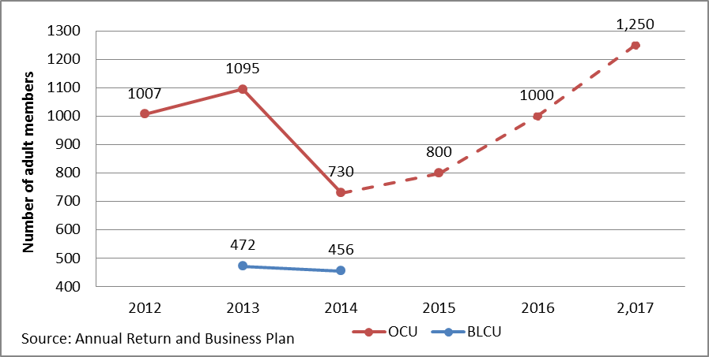

Chart 2: Total net assets (Actual)
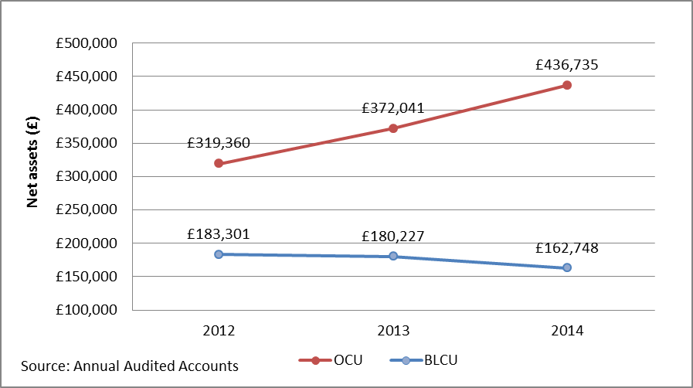

Chart 3: Total member shares and loan balances (actual and projected)
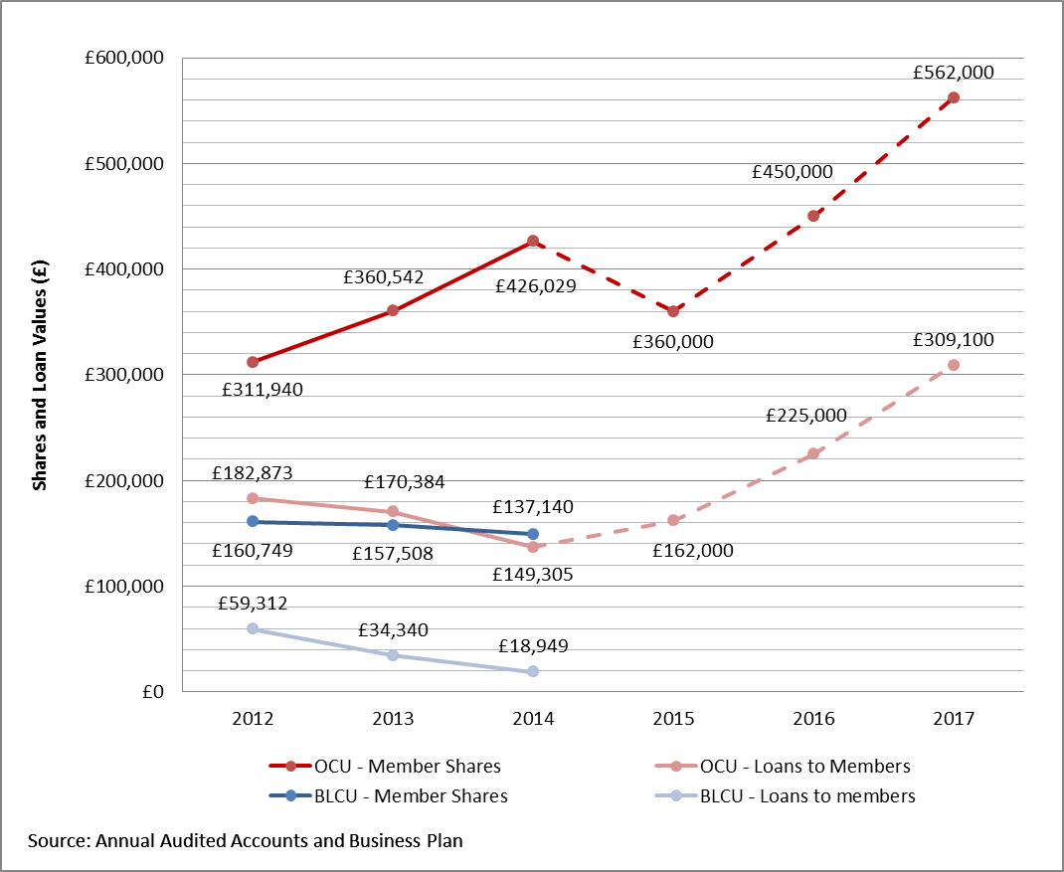

Chart 4: Net profit (actual and projected)
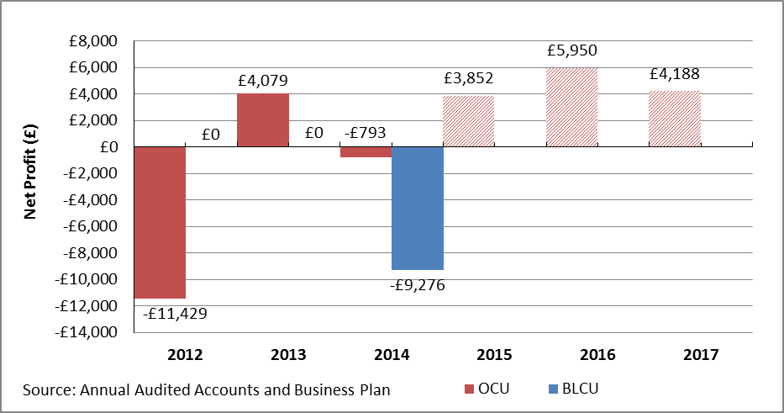

Chart 5: Income and expenditure (actual and projected)
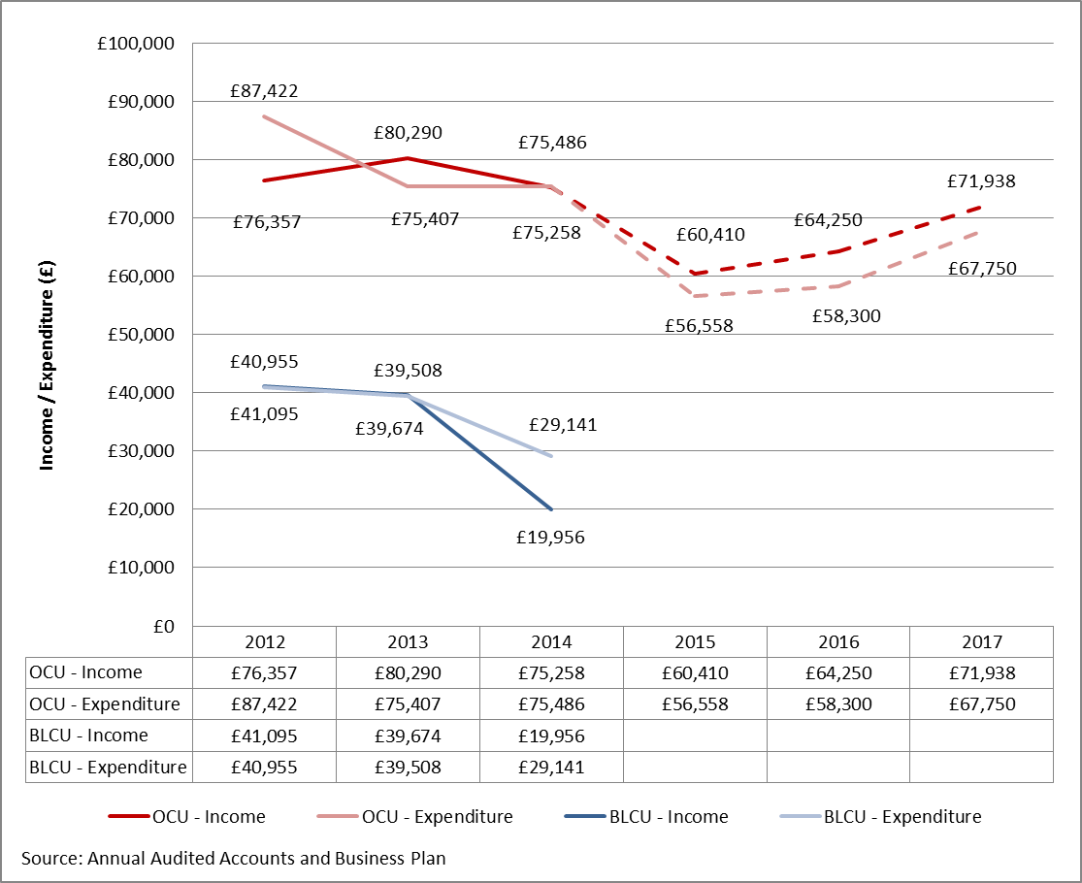

Chart 6: Capital reserves (actual and projected)
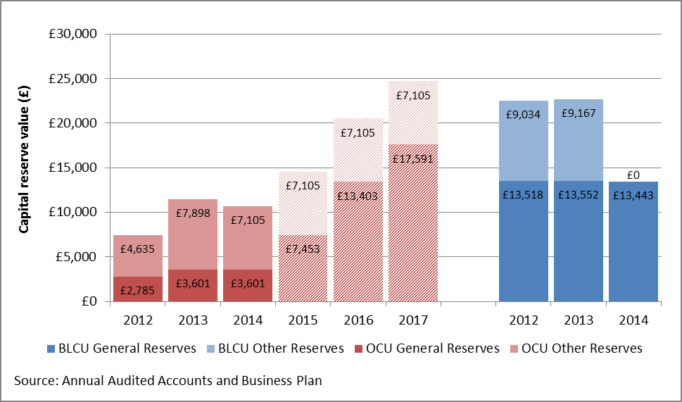

Product and service delivery:

Indicator | Oxfordshire Credit Union | Blackbird Leys Credit Union
Number of offices/outlets: | 1 (plus 2 other outlets) | 1
Website | www.oxfordshirecreditunion.co.uk | www.bblcu.org.uk
Online membership process | No | No
Free life insurance (saving/loan) | Yes | Yes
Savings  Main saving  Christmas savings  Holiday savings  Junior savings | Yes  Yes  Yes  Yes | Yes  Yes  Yes  Yes
Payroll deduction schemes | Yes (3) | No
Loans  Saving requirement/multiple  Immediate loan | Yes  Yes (but only for those on payroll deduction) | Yes  No
Loan application online | No | No
Banking services:  Prepayment debit card  PayPoint card | Yes  Yes | No  No
Online banking | No | No
Telephone banking | Yes | No

In terms of product range delivered by the two credit unions the differences are not significant. Both would benefit from diversifying their product ranges to appeal to a broader range of customers. Both a have a healthy range of saving products that expand on the main savings account, sometimes referred to share account that is a requirement for all credit union members. These additional saving products look to provide specific saving accounts for specific purposes such as Christmas or Holiday.

One common area of potential improvement is with the diversity of both credit unions’ loan portfolio. Both primarily adopt a very traditional loan policy based upon requiring perspective borrowers to demonstrate a saving track record before being able to borrow a multiple of their savings. This lending approach can be perceived as reducing risk for the credit union, as it shows the individual can make payments and some proportion of savings are retained as security. Yet, it is not necessarily a good indicator of either a borrower’s creditworthiness or their ability to afford the loan. Credit reference checks should be more readily introduced to facilitate greater numbers of applications from new members for instant access loans and help provide greater breadth of information to base creditworthiness and therefore reduce risk.

OCU has attempted to diversify its loan products to differentiate based on the size of the loan:
- ‘Standard Loans’ up to a maximum of £2,000 at an interest rate of 26.8% APR.
- ‘Larger Loans’ of between £2,000 and £7,000 at an interest rate of 12.7% APR.
It has also segmented or packaged loans for specific purposed or with specific terms to help stimulate loan demand this includes:
- ‘Switch and Match Loans’ that encourage members to transfer their loan to the credit union at a matched or reduced rate.
- ‘Family Loans’ which automatically qualifies members for a loan when they have their Child Benefit paid into the credit union.

Both currently offer life insurance on savings and loans as a free benefit of membership, which both should be using much more as a key selling point for membership of the credit union.

In terms of delivery services, OCU has partnerships with Oxford City, South Oxfordshire and Vale of White Horse Councils to enable staff to make regular saving deposits or loan repayments direct from their salary.

While BLCU has maintained its ability for members to make cash transactions over the counter at its office, OCU has replaced its own cash office with a number of electronic delivery channels and three community outreach points that look to broaden access for its membership. It has implemented a prepayment debit card to increase access to member’s money and deliver a form of transactional bank account that enables loans and saving withdrawals to be uploaded onto the debit card. This can them be used to make cash withdrawal throughout the ATM network, make purchases on the internet and telephone and pay for goods in shops (including obtaining cash-back). OCU also enable members to deposit cash deposits for savings or loan repayments via a separate PayPoint card accepted at a vast number of outlets across Oxford and nationwide.

Both credit unions have websites of varying quality, primarily used for information rather than member functionality. BLCU’s online presence is of extremely poor standard but OCU has an recently redesigned an impressive website that is mobile compatible. It would benefit from additional functionality. OCU has also moved to offer a more comprehensive telephone service with longer opening hours and enabling members to undertake a variety of functions.

Potential merger of the two credit unions in Oxford
The research interviews unveiled just how close BLCU came to actually undertaking a formal transfer of engagements into OCU to amalgamate the two credit unions. It is clear that both parties were very serious and fully committed at one point to the merger with negotiations and due diligence work undertaken. Formal approval from the BLCU membership was even obtained at an Annual General Meeting and the paperwork was completed and ready to forward to the regulator. Yet, there was a change of heart at the eleventh hour by BLCU, which prevent the submission. This centred on OCU’s new delivery model that, while retaining a face-to-face presence via a local outreach point in Blackbird Leys, would have meant the sacrifice of cash transactions. The credit union believes that this is fundamental to the needs of a large proportion of their clientele and that the most financially excluded members would struggle to adapt to accessing services via telephone, online and card facilities employed by OCU. This viewpoint is not based upon evidence or member consultation undertaken but a perception how their membership, particularly the frequent users of their office, might respond to such delivery methods. However, given the experience of OCU, where very few members were unable to make the transition, together with combining an outreach information point and local facilities that would enable cash payments to be made at 5 PayPoint outlets and free cash withdrawals at 3 outlets within 0.25 miles of the BLCU office, it would be difficult to envisage significant numbers not being able to be supported to maintain access.

The merger would have also meant the loss of their longstanding staff team and running the operation of the outlet with volunteers, which while not strongly stressed during interviews, would also have been a prominent consideration.

During interviews, both parties are disappointed about the outcome, particularly OCU who expressed some frustrations about putting significant time and effort into the process and getting so close but falling at the final hurdle. Yet, while it would appear that relations have been soured somewhat, neither party ruled out potentially revisiting the matter in the future, although remaining resolute about their particular delivery requirements.

In fact, BLCU are still actively pursuing a merger as a solution to their medium term financial issues, which is stated in their business plan as a strategic priority. In essence this would involve them operating an Oxford outpost for a larger neighbouring credit union and thus retaining both the cash facility and some degree of paid staffing resource. It is difficult to gauge whether this tactic will be successful in attracting a prospective credit union and what would be required in terms of possible commitments to secure funding locally to cover costs or reduce expenditure.

Given these circumstances, the conclusion of this research report may provide a timely opportunity for the Credit Unions to reflect on their own positions, and for the Council to facilitate a structured dialogue between them and explore potential areas of compromise and options for consideration.

Recommendations for expanding and enhancing credit union services in Oxford

Local authorities are uniquely placed to support and enable the development of modern, professional and successful credit unions, as they are locally responsive and have a clear understanding of the needs of the whole community, lead on the key local strategies within which credit unions can play a part and have the potential to provide leadership and influence within the community.

Nevertheless, any OCC strategy to support credit unions is greatly complicated by having two of them operating within in the city with two very different approaches, making it a much more delicate situation to navigate. Moreover, it is made more difficult given the local political context of Blackbird Leys Credit Union and its long history of delivering services within this deprived part of the city with its established community roots.

Having two credit unions is ultimately not productive. It duplicates effort and increasingly scarce resources as well as limiting the ability for credit union services in Oxford to flourish and fulfil their potential. It would be very easy for the Council to avoid taking any difficult decisions on this matter and either stand back, temper the provision of direct support and leave the two credit unions to develop organically. Alternatively, in the interest of trying to be seen to be fair, OCC could decide to offer equal access to the potential range of support, promotion and resources for both credit unions.

The first option, at a time when the need and opportunities for an effective credit union service to deliver significant impact has never been greater, would seem counter intuitive to the Councils priorities and challenges. It would also overlook the huge potential for Council’s to make a step change in credit union services and drive growth by implementing some of the various support recommendations identified below. The second would overlook the significant contrasts in capacity, capability and potential of the two credit unions and their differing financial circumstances. Importantly, it would also dilute the impact that the Council’s interventions could facilitate.

Given the reality of the two separate credit unions and the backdrop of pressure on public sector resources, it was clear at the outset that a wish list of unsuitable ideas and initiatives would not be useful, particularly if they would be extremely difficult to implement and secure the funding required to support a wide range of impressive sounding but hard to deliver proposals. Therefore, by exploring both good practice from elsewhere in the sector and examining the situation within each of the credit unions, the report outlines a variety of support recommendations for OCC to consider as well as changes that the credit union’s themselves could adopt to enhance and expand their services.

Recommendations to credit union services in Oxford
The following options are put forward for the credit unions to consider in terms of general good practice and broad improvements and approaches that should be undertaken:
- Become successful social businesses delivering social impact
The nature and purpose of some credit unions has often focused almost exclusively on the social objectives of credit unions to the exclusion of economic goals and long-term sustainability. This has not only led to small grant dependant credit unions but has helped foster the image of them as the ‘poor man’s bank’, which further limits their growth and development.
The most successful credit unions that are community based and address financial exclusion are first and foremost successful social enterprises. It is only as a result of running effective businesses that recognise the importance of the management and financial skills needed to run a financial institution and operate profitably that they are then also able to deliver their social goals to serve those most excluded from mainstream financial services and deliver community impact.
- Greater collaboration to achieve economies of scale
Developing individual credit unions as totally separate entities is high-cost and often limits effectiveness and growth. In other parts of the world, long-term success in expanding credit union services has been achieved through collaborative back-office delivery. In the UK, there is a growing case, particularly driven by the DWP Expansion Project, that collaboration offers a real opportunity to build scale and operational efficiency in the sector whilst retaining credit union’s unique ethos and vision. Importantly, it enables even smaller credit unions to offer the same level and quality of service as larger financial institutions.
- Broaden the membership base by product diversification
One of the key drivers of financial viability is diversifying the credit union membership to attract and serve all elements of the community. Credit unions cannot survive by serving a narrow profile of members alone, especially those on the lowest incomes, economically inactive and that are the most financially excluded. By maximising their coverage, widening their target market and prioritising the development of a range of financial products, it can attract a broader range of people to join credit unions.
Focus should be on attracting and serving low and moderate income working people by ensuring a range of more commercially attractive products and services. Credit unions need to offer a range of savings accounts, access to transactional banking, insurance and most importantly multiple loan products that are flexible and have competitive interest rates that will attract a diverse range of borrowers.
Only by purposefully refocusing its membership profile will credit unions start to become more sustainable, thus enabling them to deliver on their social goals of serving the most excluded.

- Expand delivery methods to meet the changing needs of modern consumers
If a credit union is to appeal to all sections of the community it must also ensure that the way it delivers its services match the requirements of the customers it wishes to serve and not those of the credit union.
Services must to be convenient and available at all times of the day (or night) and not just when the credit union is open. Customers also want to be able to access services via a variety of methods, without the necessity to travel to a specific location, so credit unions are deliver services remotely, utilising new technology and making full use of online and telephone facilities as well as still offering face-to-face access. No matter who you are aiming to serve, everybody would like consistent, professional and attractive services and is unwilling to wait unacceptable periods to access them, so ensuring instant access to services that provides speed of decisions and processing is being essential.
Therefore the establishment of diverse and modern electronic delivery channels is pivotal to success in attracting a large and more diverse membership. Without modern telephone, mobile and online services and efficient methods of both depositing and accessing money it is difficult to see how credit unions can expand sufficiently. Such methods also help drive down costs for credit unions and improve the quality of service to members. In addition, such electronic channels support digital inclusion of many people within the local community.
- Strong governance and management to meet business priories and new regulatory environment
Credit unions increasingly need the strong leadership of effective boards and senior management if they are going to expand and respond to new business challenges. Furthermore, the new Senior Management Regime being implemented by the Prudential Regulatory Authority (PRA) will place a much greater accountability burden on individual Directors and Boards collectively. These factors will require credit unions to place a greater focus on recruiting of skilled and professional individuals to join boards, enhancing the knowledge and capabilities of current Directors through high level training and the development of high standards of governance, competency and decision making in the boardroom.
- Increasing productivity of the loan book
It is essential that a credit union get as much of their members’ deposits out on loan as a way to generate more income and to move towards financial sustainability. Currently, the majority of credit unions have significantly more capital funds than they are able to productively lend. Successful credit unions are highly effective lenders indicated by high loan to share ratios with the World Council of Credit Union (WOCCU) recommending that between 70% and 80% of member assets need to be out on loan in order to generate sufficient income to cover costs.

Refocusing the business to serve a wider profile of members with low and moderate incomes will help support a sufficiently large and robust loan book. To help simulate loan portfolios, a credit union needs to ensure it delicately balances it risk and credit assessment with a suitable loan policy, a variety of flexible and competitively priced loan products, efficient loan systems and procedures together with convenient delivery and speed in decision making.

- Building relationships with key stakeholders to achieve greater impact
Unless credit unions build effective partnerships with a range of local organisations, they will struggle to reach across the entire community and deliver greater scale. Developing such mutually beneficial partnership with local authorities, social landlords, businesses and other local stakeholders can be time consuming and resource intensive to initially establish and maintain but are highly valuable.
- Developing payroll deduction arrangements as the foundations for growth
Maximise membership through establishing payroll deduction facilities with local authorities, primary care trusts, companies and other large employers should be a key strategic goal. The benefit for credit unions is that it provides a closed pool of potential members that it can effectively promote to and that payroll deduction payments from an individual salaries are relatively stable.

Recommendations to Oxfordshire Credit Union
The following recommendations should be implemented to make further improvements to OCU that will address some of its identified weaknesses and continue its expansion and enhancement of its services in the most effective way:
- Utilise credit reference agency information
It is recommended that the credit union explores the costs and practical deliver of accessing credit reference data to help provide detailed information on new and existing members. Unfortunately, it is difficult to see how credit unions with aspirations to grow and cover large geographic areas will be able to do so without engaging the services of one of the leading reference agencies.
Firstly and most pressing, credit reference agencies should be used to enable Identification verification to be undertaken. A credit union covering a city the size of Oxford, let alone Oxfordshire, needs to be able to facilitate membership applications with ID checking undertaken automatically and remotely. Secondly, building a loan book the size required to maintain sustain a large credit union, cannot realistically be achieved without serving new customers with immediate borrowing requirements and therefore necessitate the use of previous credit and affordability data to help identify creditworthiness. Even using a traditional model of lending, requiring members to demonstrate a savings history is by far failsafe method of guaranteeing loan repayment and often allows members to disguise overindebtedness and financial problems.
Finally, is the importance of passing information the ‘other way’ thus helping build the credit rating of credit union borrowers by uploading repayment data to the credit reference agencies.
- Develop instant online membership
In order to meet the expectations of potential customers and make it a simple, quick and pain free process to join, OCU must enable online membership. This allows a perspective member to complete their form electronically and either allows the uploading of documentation or links with credit reference data to verify the individual. This reduces the need in most case for documentation to be through the post or visit an outlet. The costs of using the service are more than outweighed by the membership growth potential and will particularly help improve access for both working residents and staff employed by payroll deduction partners. Moreover, it reduces administration cost through automatic uploading of information into the system preventing the need for manual input.
This facility is essential and should be established as soon as possible as not having it will severely limit the success of any payroll deduction arrangements and other efforts to increase membership and lending.
- Streamline loan application processes and enable completion online
Similarly, the credit union should give immediate consideration to enabling loan applications to be completed fully or partially online. Many credit unions are moving to this facility, even if it is far from an automated decision making system and still requires manual assessment. At least giving the impression to a perspective borrower that they can complete and submit the application via the credit union website matches the ease and functionality of other online lenders.
- Consider introducing of capacity based lending for new members
OCU has retained a slightly more traditional approach to lending in that, with the exception of those on payroll deduction or borrowing through the fuel buyer loan scheme, it requires an individual to be a member for at least 3 month and to have built up savings before being eligible. While this may give the credit union a sense of security in managing risk, it also limits the flexibility and attractiveness and competitiveness of loan products, especially when trying to broaden its borrowers.
Many credit unions have moved away from this savings requirement to introduce more rigorous income and expenditure assessments of capacity to repay, often combined with credit reference information. This has enabled these credit unions to make a more comprehensive assessment of an individual’s ability to afford the loan and offer new members instant access to credit. This should improve its loan assessment process but will likely result in a higher proportion of declined loans, requiring such members to continue to demonstrate a saving track record.
- Consider increasing interest rates for smallest value loans
Delivering low-value loans is extremely high cost, particularly when delivered by paid staff serving high-maintenance, high-risk members. Therefore, such loans must be priced accordingly. Research that analysed the costs involved of delivering a £300 loan at 26.7% APR showed in the two staff run credit unions, it was impossible to recover the costs incurred in raising and administering the loan.
OCU currently prices its loans under the value of £2,000 at an interest rate of 26.7% APR. It should review its loan admiration costs and consider introducing an additional pricing level for loans below say £750 or £1,000 at the new maximum interest rate for credit unions of 42.6% APR, which is still by far and away the cheapest available option for a cash loan of this value.
- Develop secure online banking facilities for members
Credit unions are increasingly creating secure online banking facilities for members to enable them to undertaken certain actions such as balance checking, fund transfer and requesting loans. Not only does this match the functionality of mainstream banks but it also increases member self-service and thus helps reduce operating costs. There are a number of relatively low-cost ‘off-the-self’ packages that can be integrated into existing websites.
- Continue to strengthen Board
As credit unions strive to expand and become larger and more complex financial businesses, it requires a step-change in skills and competency on the Board and development in strategic leadership and governance. OCU has already appears to have made progressive in developing a professional Board but will need to continue to address any gaps in knowledge and capability through recruitment and higher-level training programmes.

The credit union should look to undertake a review of the changing regulatory requirements for Director and match these to an internal skills audit in order to identify and specifically target volunteers with such expertise and experience.
- Focus growth on payroll deduction expansion
Successful credit unions are often built on former employee-only credit unions or are extremely effective at maximising membership from new and existing payroll deduction arrangements. For OCU, this is almost an untapped growth opportunity that offers the ability to effectively attract new members who are working. It currently has just three payroll partnerships and it should be a key focus to increase the number of employers offering this facility by using key influencers such as the Council to help facilitate.
As important is actually maximising the penetration levels within each of its payroll deduction arrangements. It should look to develop a stand offer/approach that promotes the benefits to both the employer and the employee of engaging. Moreover, developing stand-alone/separately branded saving and loan products available to those making payroll payments should also be considered. Once these are in place together with delivery methods to enable greater remote access, it should establish internal communications plans with each to maximise promotion and awareness amongst staff.
- Create an investment prospectus to seek capital funding from partners
While OCU currently meets capital assets provision requirements, it would benefit from securing additional investment to enable and facilitate its growth. Producing a short prospectus outlining how local stakeholders can support the credit union by making investments in the form of subordinated loans, could be used during forthcoming partnership discussions. It could also cover other key methods of engaging and supporting the credit union.
- Development of transactional banking product
Access to transaction banking has often been regarded as a gateway to financial inclusion and has become of greater importance with the onset of Universal Credit. OCU’s introduction of its prepayment debit cards offers members basic money transmission service and can be used to access cash at ATM machines, make internet and telephone purchases and obtain cash-back in shops. It has become an important lower-cost alternative for credit unions to having a fully functional current account facility for members.
This service should be further developed and packaged by OCU and promoted as a potential solution to unbanked residents or those with Post Office Card account wishing for more functionality. It should also be more prominently publicised as a benefit of partnership for local authorities and social housing providers.
- Greater use of membership data and internal communication to target existing members
A number of credit unions that are shown to be growing dramatically are not only attempting to attract new members but maximising the internal communication and selling of products and services to existing members. Stimulating existing membership and ensuring that they are fully aware of the range of products is equally important. Credit unions should be utilising internal membership data to target members based on their demographic profile and previous use or non-use of different services. Similarly, maximising the use of text and email communication is hugely important throughout the credit unions operation and marketing is highly effective. Therefore ensuring that the credit union collects and updates this information is very important.
OCU has already made attempts to improve internal communication and now has a regular newsletter but should ensure that it has an internal marketing strategy to regularly contact and promote to its own members.

Recommendations to Blackbird Leys Credit Union
In addition to a number of the suggestions proposed above, the following recommendations are specifically directed to address some of the immediate financial issues and ensure the medium-term viability of the credit union service:
- Strongly consider merger with OCU
Even with continued grant funding support, without serious address of its numerous financial issues, its medium term viability is by no means certain. The credit union itself recognises that an amalgamation with a larger credit union is its main strategy for ensuring a credit union service can continue to be delivered in the local community. Yet, while the credit union maintains that a merger is its focus, it is difficult to see how attractive such a proposition would be to a credit union outside Oxford given the current circumstances and their stated preconditions.
The breakdown of the transfer of engagements into OCU hinged on maintaining the delivery of its local office within the Blackbird Leys community and its ability to offer cash facilities to members. Negotiations should be recommenced with support from the Council to explore the options for overcoming some of these requirements to ensure that it can amalgamate before its financial circumstance worsen and a credit union facility can be maintained locally.
- Prioritise the production of a regulatory compliant business plan
BLCU does not currently have a completed business plan, which is not only a fundamental requirement of the regulator but an essential tool to help it address its current financial and operational issues. As a matter of priority, it should address this concern and ensure that it undertakes work to put in place a document that would satisfy the regulator. As a bare minimum this should include a three year financial forecast and a risk assessment of the credit union.
- Undertake an internal audit review to ensure key compliance
Given the lack of a business plan, it would be prudent for the credit union, led by the Supervisory Committee, to undertake a compliance review to satisfy itself that the main regulatory requirements are currently being met. This should use the FCA Compliance Survey to identify high-level feedback in regards to the credit unions; business model, management and governance and systems/controls. An action plan should be implemented to address any key findings.
- Increase lending to earn more income
Without a drastic improvement in lending, BLCU will struggle not to make another significant loss in 2014/15. It has prioritised raising its lending level to increase the income it earn from loans. However, as indicated earlier, sustainably increasing its loan book without accompanying delinquency will be a real challenge given its low and demographically narrow membership and its operational focus on small concentrated area of high deprivation. Moreover, its loan policy and lending process need to be improved to increase the volumes and provision of more high value and therefore profitable loans.
- Significantly reduce operating expenditure
The credit union has little choice but to accelerate its efforts to reduce its operating costs. It is likely to need to find between £5,000 to £10,000 worth of savings. While the research team only have detailed breakdown of expenditure for 2014/15, this would indicate that such savings can realistically only come from reducing it staffing levels further. This will decrease operational capacity further and will need to be substituted with volunteers to maintain delivery levels and core operations.

- Attract volunteers to support operational delivery
It is likely that whichever route the credit union chooses it will definitely require greater use of operational volunteers. It should look to promote opportunities for local residents using local networks and partners to help deliver the service. It should ensure it makes the necessary support and training preparations to be able to effectively bring these new volunteer on board.
- Strengthen the Board to meet new regulatory regime
Again, if the credit union is unable to secure a suitable merger, it will need to make a concerted effort to strengthen its Board and Supervisory Committee to address identified business continuity risks and new regulatory requirements that are due to come into force. It is likely to need to undertake a gap analysis of its management composition and recruit individuals with core skills and experience to meet any identified needs.
- Improvements to brand identity
Without a future transfer of BLCU operations into another credit union, it must dramatically improve its customer facing appearance overhauling it online, written communication and its branch. Most striking is its website, which is extremely poor and offers very little information, let alone functionality. Yet, the appearance of its office is outdated and shabby, which does not inspire confidence amongst existing and particularly perspective members. It would be easy and affordable to dramatically overhaul.

Recommendations for Oxford City Council
The following options are put forward in terms of those that can be undertaken relatively quickly by the Council and will take little or limited amount of resources to make them happen:

In order to support the development of a single credit union service in the city, Oxford City Council should look to:
- Pursue discussions to reopen merger considerations and process
The ideal scenario would be the resumption of merger discussions between the two credit unions that ultimately leads to them join forces. While this will be a challenge and by no means guaranteed given recent events, the Council should be involved in this process, adopting an active facilitation role in supporting the process to overcome some of the key obstacles.

For example, Lambeth Council, with multi-party agreement, gave direct support, leadership and funding to enable to the transfer of Lambeth Savings and Credit Union, a struggling credit union, into London Mutual Credit Union in order to enhance credit union services for its residents.

The findings of this report would provide the ideal opportunity to bring the two credit unions together, open dialogue and act as a starting point for discussions. Internal mediation and contract negotiation knowledge and expertise should be utilised and it may also be beneficial to engage independent expertise to support the initial discussions and subsequent process.
- Utilise potential Council resources and support to encourage and shape merger discussions
As outlined below, the Council has a range of possible support and funding options available to enhance credit union services. Once it has determined its strategic approach, the Council should decide to apply some of these to facilitate and help persuade both parties to engage and deliver a merger.

In order to improve the strategic development of credit unions in Oxford, Oxford City Council should look to:
- Implement a strategic approach to supporting credit unions in the city
Having taken into account the findings of this report and determining which recommendations that it wishes to take forward, the Council should develop and implement formal plan to enhance and expand credit union provision in the city. This could form an additional element of the financial inclusion strategy or be a standalone strategic plan that formalises the basis for credit union support including; what changes the Council wishes to instigate with milestones and performance targets, exactly how it will deliver the change and what resources will be provided. This will also ensure that the Councils approach is clearly defined and the entire organisation is formally engaged in the delivery of the strategy.
- Inclusion of credit union services within other Council delivery strategies
OCC already makes reference to the work of the credit union to help deliver some of the aims of its Financial Inclusion Strategy. It could look to broaden this and include it within other appropriate local strategic delivery plan targeting worklessness and unemployment, fuel poverty, welfare reform, advice and debt reduction.

In order to increase awareness and maximise take up of the credit union amongst its local audience, Oxford City Council should look to:
- Maximise OCC staff awareness and take-up of the credit union.
One of the simplest and most important things the Council could do is encourage its own staff to join the credit union. Like, a large proportion of other local authorities, it already has a payroll deduction arrangement in place with OCU but unfortunately only a handful of staff are currently using it. Once the Council is satisfied that progress has been made on a number of the recommendations, it should work with OCU to encourage greater staff awareness and participation to help deliver a multiple benefit.

Firstly, it will of course support the credit union’s growth by providing new members and sources of savings and loan. Payroll deduction facilities via credit unions also offer a staff benefit that helps improve the financial wellbeing of its own employees by encouraging savings and providing access to affordable borrowing sources instead of high cost alternatives such as payday loans. This is demonstrated amongst other local authorities who have their own in-house credit unions just for staff or those that proactively promote their local credit unions. Finally, it will also build first hand appreciation of the credit union amongst staff who will then be more likely to recognise the potential benefits to local residents within the context of their own work roles.

The Council could bring together interested staff from across the organisation with representatives from the credit union to explore effective methods of reaching and engaging staff. These should be developed into an action plan with a target of say 5% of staff joining the credit union each year. All key internal marketing and promotional channels should be used and communication department staff engaged to help deliver.

There are also examples of extremely successful staff incentives schemes within a number of social housing providers that have resulted in well over a third of staff at Notting Hill Housing, Circle Housing, and Octavia Housing joining their respective credit unions. A similar staff incentive scheme may also be explored and costed for OCC staff to identify if viable.
- High profile membership sign-up of senior staff within the Council
There is nothing like leading by example and the senior leadership team should be encouraged to become members of the credit union with accompanying promotion to help raise awareness internally and externally. It will also build understanding and ownership at a senior level within the organisation.
- Every local Councillor encouraged to become a member of the credit union
The Council should challenge every one of the 48 ward Councillors to become a member of the credit union if they are not already. It should contact each Councillor, providing information and strongly encouraging membership. Moreover it should plan a ‘mass’ sign-up event, where credit union representatives are on-hand to accept membership applications at a full Council meeting with follow-up publicity in in-house and external media channels.
- Exert influence to actively engage large local businesses and suppliers to offer payroll provision
The Council should use it position and authority to directly approach senior staff and where appropriate Board members within large employers in Oxford. This could at least be targeted at the 24 firms based in the city with at least 200 employees (see Appendix 5) and its suppliers of all large contracts. The Council should seek introductory meetings to explore the benefits and what it would entail to establish and operate. This should first and foremost seek commitments to establish a payroll deduction facility and to widely promote the service to its staff. Moreover, this could then lead to wider engagement by the organisations to actively support the credit unions development as part of their Corporate Social Responsibility agenda. For every high profile company joining, local publicity should be undertaken to help wider credit union promotion.
- Position support for credit unions alongside Living Wage requirements.
OCC may also want to explore opportunities to combine support for the credit union with the Council’s status and wider work around the Living Wage. The two agendas would complement each other well with the Council’s encouragement of local firms and its perspective contractors to engage with the Living Wage being used to introduce other ways of supporting employees such as promoting access to credit union amongst their staff.
- Approach senior representatives at social housing providers to engage with the credit union
The Council should identify those social housing providers with large stock concentrations in Oxford as well as the rest of Oxfordshire and actively co-ordinate their involvement with the credit union. Senior staff and Board members should be contacted to facilitate introductions to the credit union with a focus on the benefits that the credit union can deliver for residents, especially following the implementation of Universal Credit.

It should host an initial meeting and encourage attendance from all local housing providers. The aim should to be to secure commitments to at least devise and implement a planned awareness raising campaign to all their residents. Furthermore, and particularly amongst those with large numbers of residents and staff, a more in depth partnership should be pursued at follow-up meetings. This should explore possible payroll deduction facilities for staff, provision of resources to support delivery, capacity training for staff and innovative approaches to engaging residents at different points of their tenancy.
- Facilitate further partnership work with key local stakeholders
Similarly, the Council should be helping the credit union to engage and involve other local service providers, agencies and networks whose customers would benefit from accessing their services. This should include work to engage with the business and enterprise community, housing, education and young people, older people, voluntary and community organisations and faith groups. Again, one of the most productive methods would be for the Council to organise and host a series of events aimed at each subgroup of stakeholders that is tailored to details how the credit union can specifically help their clients and what support it needs from them.
- Lead a promotional campaign to increase awareness across Oxford
An extremely important role that the Council should also play is using its position to raise awareness within the city of the credit union. As is the case nationally, there are extremely low levels of credit union recognition and the Council is ideally place to help address this locally. It should recognise the credit union as one of the Council’s key communication priorities and bring together credit union representatives and key staff to help devise key promotional messages and produce a comprehensive marketing and communications strategy specifically for the credit union. This should include general promotional opportunities and channels that use existing Council advertisement, publication and communication opportunities and could continually be used to reach local residents with messages about the credit union including:
- OCC website – with its own credit union section and regular homepage banners, pop-ups, articles and links.
- Your Oxford – including adverts in every edition and regular articles and inserts
- Presence at OCC organised community events throughout the year
- Literature such as posters, leaflets and banners distributed and displayed in OCC offices and facilities (such as sports facilities, libraries, community centres etc)
- Inclusion on reception area multimedia screen content
- Programme of pop-up presence at specific locations
- Social media strategy
- Messages on Council phone and email signature

In addition, it should also look to identify a number of existing communication campaigns on broader issues where there is synergy with the credit union, for example campaigns on debt, welfare reform, paying Council Tax, and include relevant information.
Finally, a number of specific campaigns should be developed and rolled out during the period, particularly around themes such as; affordable borrowing alternatives to specific types of high cost loans (payday loans, credit cards, home credit) or at specific times of year (Christmas or back to school) and joining the credit union as an ethical and local banking service.
- Incorporate credit union services and promotion into appropriate Council services and customer interactions.
The Council should examine its own services and resident interaction points to begin to identify opportunities for incorporating promotional literature within the workflow process where the credit union could provide a support or solution for residents. Reviewing the various Council departments/services or communication interactions where specific credit union literature or direct referrals could be included would be extremely valuable for both parties.
There are a vast array of examples but could include, pre-tenancy stages for social housing allocation including specific information on using credit unions to save for deposits, access banking services and borrow affordably to furnish new properties, to including literature on saving or borrowing affordably for school uniforms in communications notifying of school placements and at the end of Spring and Summer terms.
- Train frontline OCC staff on the credit union
To complement its marketing and communication work, the Council should plan a programme of short sessions for key frontline staff to raise internal awareness and build appreciation the benefits for residents of joining in specific Council areas. This could either be developed as a new standalone training module or incorporated into existing training sessions for frontline staff.

In order to help resource and strengthen credit union services, Oxford City Council should:
- Maintain short-term revenue funding
Despite current public sector spending restraint, there is an immediate need for OCC to maintain its grant funding support for both the credit union services. Last year the Council provided £20,000 revenue funding for OCU via its commissioning program and £7,000 revenue funding for BLCU through the social inclusion programme. Currently, no funding commitments have been provided to either credit union but as the financial review shows, without the Council’s financial support the two credit unions would struggle to cover their costs and could be forced to close without securing alternative funding sources.
Instead, the Council needs to review and confirm its overall approach to funding the two credit union services, ideally moving away from an annual grant to a more strategic and decreasing funding commitment over a number of years together with alternative capital investment. This way it gives the credit unions the ability to plan their finances and plan for reducing external funding but also enables the Council to use these resources to help shape effective credit union services. The aim should be use its resources to encourage a transfer of engagements in the short-term as well as the movement towards self-sufficiency overtime. OCU are clearly further down this path and within the next three years should reduce their grant dependency down to approximately £10,000 per year, equivalent to less than 15% of their income. In contrast, BLCU have stated that to deliver services to low income households there will always be a need for local government support.

The exact level of financial commitment would require careful consideration but given the timescales and consequences of ceasing funding commitments, it would be appropriate to at least maintain last year’s funding commitments again in 2015. It would then be shrewd to outline future funding and support proposals for each credit union. For OCU, this would likely involve a graduated reduction to funding commitments that could halve each year to a level of £5,000 by 2017. With BLCU, the Council could use its funding to proactively encourage a merger with the prospect of support ceasing should this not be achieved. Furthermore, it may wish to offer on-going resources to ensure a face to face information point can be delivered locally.
All investment in credit unions should be contingent on meeting specific requirements, such as undertaking a merger as well as conditional upon the achievement of certain financial and operational targets, which should broaden focus not just on membership growth, but also on financial growth in savings, loans and assets.
- Continue to monitor the financial positions of both credit unions
Given the financial issues highlighted during this report, it would be prudent of OCC to request ongoing financial information to observe the progress of both credit unions. The annual accounts and annual return should be available within 6 months of the end of September 2015 and should measure improvements or deterioration to key financial indicators and can be used to inform and the Councils actions to support each credit union.
- Make one-off capital grants available to improve technology use and deliver enhanced services
As has been identified, the OCU would benefit from further use of online technology and software upgrades to improve the service delivery and increase access. Without capital funding, a number these much needed improvements may not happen or will need to wait for funding to be identified and secured. Therefore, the Council should consider providing one-off funding for specific enhancements to create secure internet banking facilities, enable online membership and loan application facilitates together with greater integration of phone, text and email communication.
The extent and exact costs of such technology investment would need to be explored with OCU but is likely be in the region of £10,000 to £15,000 for such upgrades to their systems.
- Longer term capital invest to build financial strength of the credit union
Without sufficient capital, credit unions will be restricted in their growth potential. Local authorities are increasingly becoming strategically important sources of investment to help credit unions adapt, strengthen financially and meet their capital requirements as they expand. As identified earlier, OCU would benefit from investment to strengthen their balance sheet and ensure their capital levels keep up with their growth. There are two options for such investment.

Firstly, deferred shares could be deposited by the Council, which would count towards the credit union’s capital position. However, this is a far less appealing form of investment as it is transferable, but not withdrawable, and therefore are generally repayable only on winding-up or dissolution of the credit union, after all creditors have been repaid.

A more appealing and increasingly common method of local authority investment would be in the form a long-term, interest free sub-ordinated loan. For example, over the last 5 years London Capital Credit Union secured subordinated loans from Islington Council (£250,000) and Haringey Council (£750,000). Credit Unions operating under Version 1 requirements must transfer 20% of surplus to general reserve, until such time as the reserve is built up to 10% of assets. This protects the credit union viability and financial stability. A subordinated loan has the dual benefits of maintaining this required level of capital in the general reserve as it grows, but also allowing the credit union to release its surpluses to fund additional marketing, service delivery and operational development.

The potential initial investment required would be significantly less than these examples due to the smaller financial scale of OCU’s operations and would instead be in the region of between £50,000 and £100,000 with a 10 year term.
- Help facilitate volunteering within the credit unions to support operations
The Council should work with the credit union and local and national volunteering providers (such as Volunteer Centre Oxford) to promote opportunities for local people to get involved with their local credit union. Moreover, it should also promote and actively encourage its own staff to use their voluntary time to take up volunteering opportunities with the credit union.
These could range from individuals using their existing skills and expertise (such as IT, finance, business planning and growth etc) to either join the Board or undertake a specific one-off role or task, to operational volunteers to help with marketing or running a weekly face-to-face community outlet. Council staff could also help to champion and promote take-up internally amongst other colleagues.
- Make Council facilities available to the credit union
Making appropriate Council outlets / facilities available in-kind to the credit union for new community outreach points would support the delivery of face-to-face services. This mapping of potential sites should be undertaken with the credit union to identify current gaps and ensure that locations are suitable and can be resourced with local volunteers.
- Explore potential contractual arrangements for the credit union to deliver services for the Council
Across the country, there is growing expectation that credit unions should not be just the recipients of support but rather would be active participants in mutually-beneficial initiatives and programmes. Alongside this expectation, there has been a move towards more contractual arrangements between credit unions and local authorities. There are a number of examples of such arrangements where both parties have worked together to develop specific interventions, products to meet specific needs amongst residents or credit unions administering elements of Council services. For example, there are credit unions administering specific grant or loan schemes such as Local Welfare Assistance or Home Rescue Loan schemes on behalf of local authorities, designing and operating specific financial products to address issues such as loan product for furnishing new Council properties, or opening transactional accounts for Council payments or reimbursements to be made when a resident doesn’t have a transactional account.

With OCU’s pre-payment debit card, it opens up the range of new opportunities for the Council work with the credit union to respond to the direct payments and its personalisation agenda. This exercise should be explored when potential Council services and resident interaction points are reviewed with a range of opportunities identified for consideration.

Appendix

Appendix 1 - Audited Annual Accounts: Income and Expenditure (BLCU and OCU)

 | Blackbird Leys Credit Union |  |  |  |  |  | Oxfordshire Credit Union
 | 2012 | 2013 | 2014 |  |  | 2012 |  | 2013 | 2014
Income
Interest from loans to members | - | - | - |  |  | £41,806 |  | £40,918 | £38,587
Investment income | - | - | - |  |  | £1,818 |  | £4,019 | £2,823
Subtotal | - | - | - |  |  | £43,624 |  | £44,937 | £41,410
Other income
Grants | - | - | - |  |  | £25,500 |  | £23,750 | £28,298
Donations | - | - | - |  |  | £6,651 |  | £9,249 | £2,517
Entrance and exit fees | - | - | - |  |  | £122 |  | £826 | £131
Bad debt recovered | - | - | - |  |  | £300 |  | £1,270 | £2,677
Other | - | - | - |  |  | £160 |  | £258 | £225
Subtotal | - | - | - |  |  | £32,733 |  | £35,353 | £33,848
TOTAL INCOME | £41,095 | £39,674 | £19,956 |  |  | £76,357 |  | £80,290 | £75,258
Expenditure
Bad debts | - | - | - |  |  | £26,757 |  | £20,769 | £14,041
Administrative Expenses | £40,955 | £39,508 | £29,141 |  |  | £60,665 |  | £54,638 | £61,445
TOTAL EXPENDITURE | £40,955 | £39,508 | £29,141 |  |  | £87,422 |  | £75,407 | £75,486
Operating surplus (deficit) | £140 | £166 | -£9,185 |  |  | -£11,065 |  | £4,883 | -£228
Corporation Tax | £140 | - | £91 |  |  | £364 |  | £804 | £565
Net Profit | - | £0 | -£9,276 |  |  | -£11,429 |  | £4,079 | -£793
Dividends | - | - | - |  |  | -£1,329 |  | - | -
Transfer to general reserves | - | - | -£9,167 |  |  | - |  | £816 | -
Transfer to other reserves | - | - | -£109 |  |  | -£12,758 |  | £3,263 | -£793

Appendix 2 - Audited Annual Accounts: Balance Sheets (BLCU and OCU)

 | Blackbird Leys Credit Union Oxfordshire Credit Union
 | 2012 | 2013 | 2014 |  | 2012 | 2013 | 2014
Fixed Assets
Tangible fixed assets | £143 | - | - |  | £1,117 | - | -
Investments | £61,756 | £157,774 | £106,996 |  | - | - | -
Subtotal | £61,899 | £157,774 | £106,996 |  | £1,117 | £0 | £0
Current Assets
Loans to members | £59,312 | £34,340 | £18,949 |  | £182,873 | £170,384 | £137,140
Less provision for bad debt | -£11,283 | -£9,730 | -£5,318 |  | - | - | -
Debtors (inc interest due) | £626 | £356 | - |  | £430 | £1,487 | £10,702
Fixed rate bond | - | - | - |  | £30,000 | £25,000 | £25,000
Bank deposit account | - | - | - |  | £55,556 | £127,415 | £142,578
Cash at bank | £91,567 | £14,978 | £49,198 |  | £58,108 | £56,559 | £129,900
Prepaid Expenses | £221 | £977 | £210 |  | - | -
Subtotal | £140,443 | £40,921 | £63,039 |  | £326,967 | £380,845 | £445,320
Current liabilities
Loan repayable | - | - | - |  | £0 | £5,000 | £4,950
Audit fees | - | - | - |  | £3,360 | £3,000 | £3,000
Other accruals | - | - | - |  | - | - | £71
Corporation tax payable | - | - | - |  | £364 | £804 | £564
Subtotal | - | - | - |  | £3,724 | £8,804 | £8,585
Creditors
Junior deposits | £9,936 | £6,600 | £5,752 |  | - | - | -
Grants | £7,643 | £10,456 | £354 |  | - | - | -
Corporation Tax | £321 | £452 | £102 |  | - | - | -
Sundry creditors & accruals | £1,141 | £960 | £1,079 |  | - | - | -
Subtotal | £19,041 | £18,468 | £7,287 |  | £5,000 | £0 | £0
Net Current Assets | £121,402 | £22,453 | £55,752 |  | £318,243 | £372,041 | £436,735
TOTAL NET ASSETS | £183,301 | £180,227 | £162,748 |  | £319,360 | £372,041 | £436,735
Capital and Reserve
Members share balance | £160,749 | £157,508 | £149,305 |  | £311,940 | £360,542 | £426,029
General reserves | £13,518 | £13,552 | £13,443 |  | £2,785 | £3,601 | £3,601
Other reserves | £9,034 | £9,167 | - |  | £4,635 | £7,898 | £7,105
 | £183,301 | £180,227 | £162,748 |  | £319,360 | £372,041 | £436,735

Appendix 3 – Deprivation levels in Oxford

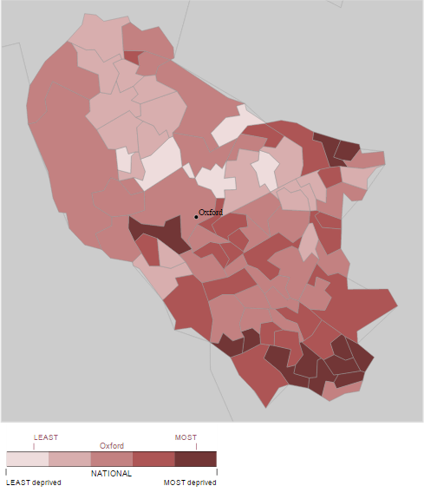
Source: Indicies of Deprivation (2010) by Lower Super Output Areas

Number of people in Oxford who are income deprived | 16,788

Lower Super Output Areas (LSOA) within top 20% most deprived in the country
LSOA | Ward | Deprivation Extent | Rank of extent
Oxford 018B | Northfield Brook | 45.23 | 3,165
Oxford 016F | Rose Hill and Iffley | 44.49 | 3,346
Oxford 018A | Blackbird Leys | 42.85 | 3,740
Oxford 018C | Northfield Brook | 42.46 | 3,844
Oxford 005B | Barton and Sandhills | 41.74 | 4,043
Oxford 005A | Barton and Sandhills | 41.57 | 4,096
Oxford 017B | Blackbird Leys | 40.43 | 4,438
Oxford 016A | Littlemore | 38.45 | 5,037
Oxford 008B | Carfax | 37.80 | 5,245
Oxford 017A | Blackbird Leys | 37.68 | 5,296
Oxford 016E | Rose Hill and Iffley | 36.80 | 5,575
Oxford 017D | Northfield Brook | 35.24 | 6,133
Oxford 016B | Littlemore | 33.72 | 6,651

Appendix 4 - Social housing providers in Oxford (and Oxfordshire)

Social Housing Providers | Total Stock Numbers
Social Housing Providers | Oxford | Rest of Oxfordshire
A2Dominion Group Ltd | 1,943 | 622
Oxford Citizens HA Ltd | 1,372 | 1,343
Catalyst Housing Ltd | 1,244 | 479
Home Group Ltd | 299 | 227
Anchor Trust | 215 | 155
Bromford Housing Association | 134 | 547
SOHA Housing Limited | 85 | 5,249
BPHA Limited | 75 | 62
The Riverside Group Ltd | 69 | -
Jephson HA Ltd | 68 | 117
Advance Housing & Support Ltd | 57 | 192
Hastoe Housing Association Limited | 55 | 1
Sovereign Housing Association Ltd | 36 | 7,277
Wyndham Housing Association Ltd | 33 | -
Thames Valley Charitable HA Ltd | 27 | 299
Housing 21 | 26 | 206
Bromford Home Ownership Ltd | 10 | 17
Frontis | 2 | -
Co-op Homes (South) Ltd | 1 | 1
Moat Homes Limited | 1 | 7
Shepherds Bush Housing Group | 1 | -
Southern Housing Group Ltd | 1 | 50
Ability Housing Association | - | 21
Affinity Sutton Homes | - | 42
Buckinghamshire HA Ltd | - | 4
Circle Housing | - | 22
Cottsway Housing Association Ltd | - | 3,861
Dimensions UK Ltd | - | 17
East Homes Ltd | - | 1
English Rural Housing Association Ltd | - | 33
Hanover Housing Association | - | 162
Henley & District Housing Trust Ltd | - | 67
London & Quadrant Housing Trust | - | 194
MacIntyre Housing Association Ltd | - | 4
Methodist Homes Housing Association | - | 23
National Council of YMCAs | - | 31
Notting Hill Home Ownership HA Ltd | - | 1
Paradigm Housing Association | - | 361
Places for People Homes Ltd | - | 11
Raglan Housing Association Ltd | - | 117
Sanctuary Housing Association | - | 5,898
Thame & District HA Ltd | - | 72
The Abbeyfield Society | - | 22
The Guinness Partnership | - | 210
Wandle Housing Association Ltd | - | 1
TOTAL | 5,754 | 28,026
Source: http://www.nhfdirectory.co.uk/authority/

Appendix 5 – Number of Employers based in Oxford (with over 200 staff based in Oxfordshire)

Employer | Total staff | Staff in Oxfordshire | Location
Oxfordshire County Council | 22,000 | 22,000 | Oxford
The University Of Oxford (includes OUP) | 18,000 | 18,000 | Oxford
Oxford Radcliffe Hospitals NHS Trust | 10,136 | 10,136 | Oxford
BMW (UK) Manufacturing | 8,000 | 3,700 | Oxford
Oxford Brookes University | 2,800 | 2,800 | Oxford
NHS Oxfordshire | 2,500 | 2,500 | Oxford
Oxfordshire & Buckinghamshire NHS Trust | 3,008 | 2,144 | Oxford
Oxford City Council | 1,300 | 1,300 | Oxford
Oxford & Cherwell Valley College Oxford | 1,000 | 1,000 | Oxford
Unipart Group | 8,200 | 1,000 | Oxford
Oxfam | 1,856 | 822 | Oxford
Nielsen | 635 | 635 | Oxford
Amey plc | 11,000 | 550 | Oxford
City of Oxford Motor Services (Oxford Bus Company) | 543 | 543 | Oxford
John Wiley & Sons | 629 | 455 | Oxford
Blackwell UK | 1,604 | 400 | Oxford
Stagecoach | 18,000 | 400 | Oxford
Timbmet Group | 364 | 364 | Oxford
Four Pillars Group | 720 | 358 | Oxford
Dragon School Trust | 270 | 270 | Oxford
Grafton Merchanting GB Ltd | 4,600 | 260 | Oxford
Becton, Dickinson U.K. Ltd | 932 | 240 | Oxford
Symm Group Ltd | 276 | 231 | Oxford
Evotec (UK) Ltd | 500 | 218 | Oxford
TOTAL | 118,873 | 70,326
Source: Insight Oxfordshire – Top 100 Employers (2011)

Based on 154,800 estimated population of Oxford in June 2013 (www.oxford.gov/population_statistics_occw)
Common Bond’ is the term used to describe the eligible membership qualification for a credit union and can include a mixture of residing or working within a specific geographical area and/or association or employment with a specific organisation or corporate body.
Bad debt provisions are the monies that the regulator requires credit unions to set aside because of payment arrears and the likelihood that some of the loans may subsequently have to be written off.
Representative of its risk adjusted level of reserves as a proportion of its total assets.
Note - the BLCU Business Plan does not contain any financial forecasts.
The minimum regulatory requirement is a capital to asset ratio of 3%. If a credit union has not reached this level by September 2014 or drops below this levels for a sustained period and is unable to address this position, it will be instructed to transfer engagements or forced to close.
Bank of England Prudential Regulation Authority – Credit Union Quarterly Statistics (December 2014) for England, Scotland and Wales.
Oxfordshire Credit Union - Audited Annual Accounts at 30/0914 or Annual Return at 30/09/14
Blackbird Leys Credit Union - Audited Annual Accounts at 30/0914 or Annual Return at 30/09/14
Blackbird Leys Credit Union - Audited Annual Accounts or Annual Return at 30/09/14
With exception of OCU members that are making payment via payroll deduction or fuel buying loan scheme.
Number of outlets obtained at www.paypoint.com and www.link.co.uk/ATMLocator using postcode OX4 6HW (accessed on 25/06/15).
Jones, P, (2008) ‘From tackling poverty to achieving financial inclusion: The changing role of British credit unions in low-income communities’, Journal of Socio-Economics, 37: 2141-54.
In the first credit union, the income generated ranged from a loss of £39.60 to a surplus of £20.36 (with monthly electronic repayments) but with fully recovery calculation all loans resulted in a loss. In the second credit union, the typical loss on was calculated as £30.41.
Representing 64% of its income from grants and donations or 26% of its total income in 2014.
Representing 45% of its income from grants and donations or 35% of its total income in 2014.
Indices of Income Deprivation (2010)
Where 1 is most deprived and 32,482 is least deprived.

